|  |  |  |  |  |  |  |  |  |  |  |
| --- | --- | --- | --- | --- | --- | --- | --- | --- | --- | --- |
| **Test Case ID** | | 00 | **Test Case Description** | | Start Application | | | | | |
|  |  |  |  |  |  |  |  |  |  |  |
|  |  |  |  |  |  |  |  |  |  |  |
| **Date Tested** | | 12-Apr-2019 | | **Test Case (Pass/Fail/Not Executed)** | | Pass | |
|  |  |  |  |  |  |  |  |  |  |  |
| **S #** | **Prerequisites:** | | |  |
| 1 | JDK 11 | | |  |
|  |  |  |  |  |  |  |  |  |  |  |
| **Test Scenario** |  | | | | | |  |  |  |  |
|  |  |  |  |  |  |  |  |  |  |  |
| **Step #** | **Step Details** | | **Expected Results** | | **Actual Results** | | | **Pass / Fail / Not executed / Suspended** | | |
|
| 1 | Open application | | Staff Selection Menu | | As expected | | | Pass | | |

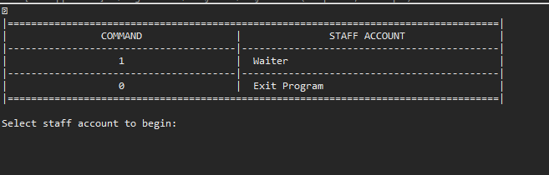

|  |  |  |  |  |  |  |  |  |  |  |
| --- | --- | --- | --- | --- | --- | --- | --- | --- | --- | --- |
| **Test Case ID** | | 00-1 | **Test Case Description** | | Select Staff 1 | | | | | |
|  |  |  |  |  |  |  |  |  |  |  |
|  |  |  |  |  |  |  |  |  |  |  |
| **Date Tested** | | 12-Apr-2019 | | **Test Case (Pass/Fail/Not Executed)** | | Pass | |
|  |  |  |  |  |  |  |  |  |  |  |
| **S #** | **Prerequisites:** | | |  |
| 1 | 00 | | |  |
| 2 |  | | |  |
| 3 |  | | |  |
| 4 |  | | |  |
|  |  |  |  |  |  |  |  |  |  |  |
| **Test Scenario** |  | | | | | |  |  |  |  |
|  |  |  |  |  |  |  |  |  |  |  |
| **Step #** | **Step Details** | | **Expected Results** | | **Actual Results** | | | **Pass / Fail / Not executed / Suspended** | | |
|
| 1 | Input ‘1’ | | Show Main Menu | | As expected | | | Pass | | |

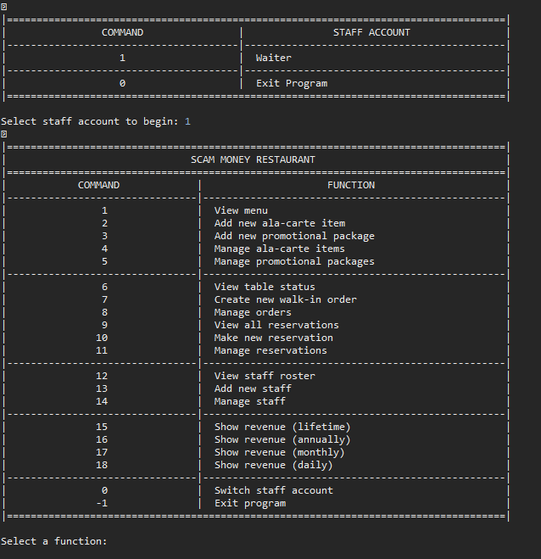

|  |  |  |  |  |  |  |  |  |  |  |
| --- | --- | --- | --- | --- | --- | --- | --- | --- | --- | --- |
| **Test Case ID** | | 00-3 | **Test Case Description** | | Invalid Input | | | | | |
|  |  |  |  |  |  |  |  |  |  |  |
|  |  |  |  |  |  |  |  |  |  |  |
| **Date Tested** | | 12-Apr-2019 | | **Test Case (Pass/Fail/Not Executed)** | | Pass | |
|  |  |  |  |  |  |  |  |  |  |  |
| **S #** | **Prerequisites:** | | |  |
| 1 | 00 | | |  |
| 2 |  | | |  |
| 3 |  | | |  |
| 4 |  | | |  |
|  |  |  |  |  |  |  |  |  |  |  |
| **Test Scenario** |  | | | | | |  |  |  |  |
|  |  |  |  |  |  |  |  |  |  |  |
| **Step #** | **Step Details** | | **Expected Results** | | **Actual Results** | | | **Pass / Fail / Not executed / Suspended** | | |
|
| 1 | Input unexpected value | | Error message | | As expected | | | Pass | | |

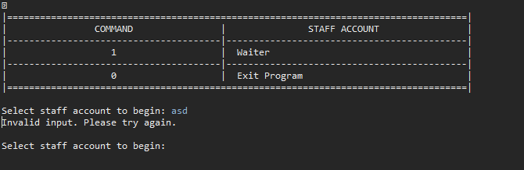

|  |  |  |  |  |  |  |  |  |  |  |
| --- | --- | --- | --- | --- | --- | --- | --- | --- | --- | --- |
| **Test Case ID** | | 01-1 | **Test Case Description** | | View Food Menu | | | | | |
|  |  |  |  |  |  |  |  |  |  |  |
|  |  |  |  |  |  |  |  |  |  |  |
| **Date Tested** | | 12-Apr-2019 | | **Test Case (Pass/Fail/Not Executed)** | | Pass | |
|  |  |  |  |  |  |  |  |  |  |  |
| **S #** | **Prerequisites:** | | |  |
| 1 | 00-1 | | |  |
| 2 |  | | |  |
| 3 |  | | |  |
| 4 |  | | |  |
|  |  |  |  |  |  |  |  |  |  |  |
| **Test Scenario** |  | | | | | |  |  |  |  |
|  |  |  |  |  |  |  |  |  |  |  |
| **Step #** | **Step Details** | | **Expected Results** | | **Actual Results** | | | **Pass / Fail / Not executed / Suspended** | | |
|
| 1 | Input ‘1’ | | Display food menu | | As expected | | | Pass | | |

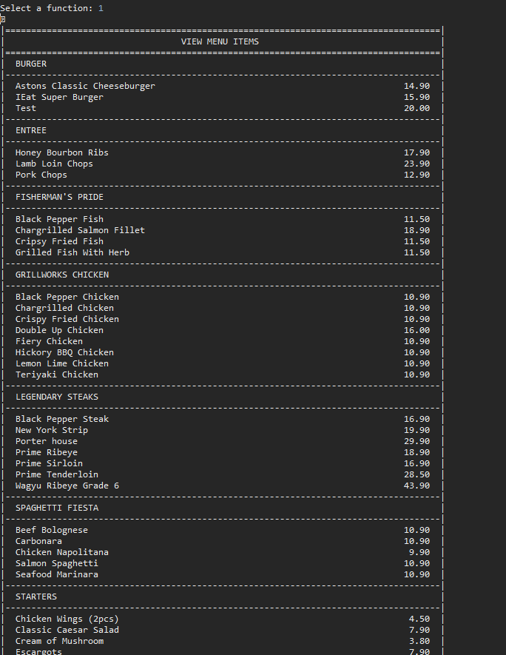

|  |  |  |  |  |  |  |  |  |  |  |
| --- | --- | --- | --- | --- | --- | --- | --- | --- | --- | --- |
| **Test Case ID** | | 01-1 | **Test Case Description** | | Exit Menu | | | | | |
|  |  |  |  |  |  |  |  |  |  |  |
|  |  |  |  |  |  |  |  |  |  |  |
| **Date Tested** | | 12-Apr-2019 | | **Test Case (Pass/Fail/Not Executed)** | | Pass | |
|  |  |  |  |  |  |  |  |  |  |  |
| **S #** | **Prerequisites:** | | |  |
| 1 | 01 | | |  |
| 2 |  | | |  |
| 3 |  | | |  |
| 4 |  | | |  |
|  |  |  |  |  |  |  |  |  |  |  |
| **Test Scenario** |  | | | | | |  |  |  |  |
|  |  |  |  |  |  |  |  |  |  |  |
| **Step #** | **Step Details** | | **Expected Results** | | **Actual Results** | | | **Pass / Fail / Not executed / Suspended** | | |
|
| 1 | Input 0 | | Return to main menu | | As expected | | | Pass | | |
|  |  | |  | |  | | |  | | |
|  |  | |  | |  | | |  | | |
|  |  | |  | |  | | |  | | |
|  |  | |  | |  | | |  | | |
|  |  | |  | |  | | |  | | |

|  |  |  |  |  |  |  |  |  |  |  |
| --- | --- | --- | --- | --- | --- | --- | --- | --- | --- | --- |
| **Test Case ID** | | 01-02 | **Test Case Description** | | Invalid Input | | | | | |
|  |  |  |  |  |  |  |  |  |  |  |
|  |  |  |  |  |  |  |  |  |  |  |
| **Date Tested** | | 12-Apr-2019 | | **Test Case (Pass/Fail/Not Executed)** | | Pass | |
|  |  |  |  |  |  |  |  |  |  |  |
| **S #** | **Prerequisites:** | | |  |
| 1 | 01 | | |  |
| 2 |  | | |  |
| 3 |  | | |  |
| 4 |  | | |  |
|  |  |  |  |  |  |  |  |  |  |  |
| **Test Scenario** |  | | | | | |  |  |  |  |
|  |  |  |  |  |  |  |  |  |  |  |
| **Step #** | **Step Details** | | **Expected Results** | | **Actual Results** | | | **Pass / Fail / Not executed / Suspended** | | |
|
| 1 | Input unexpected value | | Error Message | | As expected | | | Pass | | |
|  |  | |  | |  | | |  | | |
|  |  | |  | |  | | |  | | |
|  |  | |  | |  | | |  | | |
|  |  | |  | |  | | |  | | |
|  |  | |  | |  | | |  | | |

|  |  |  |  |  |  |  |  |  |  |  |
| --- | --- | --- | --- | --- | --- | --- | --- | --- | --- | --- |
| **Test Case ID** | | 02 | **Test Case Description** | | Add new ala-carte item | | | | | |
|  |  |  |  |  |  |  |  |  |  |  |
|  |  |  |  |  |  |  |  |  |  |  |
| **Date Tested** | | 12-Apr-2019 | | **Test Case (Pass/Fail/Not Executed)** | | Pass | |
|  |  |  |  |  |  |  |  |  |  |  |
| **S #** | **Prerequisites:** | | |  |
| 1 | 00-1 | | |  |
| 2 |  | | |  |
| 3 |  | | |  |
| 4 |  | | |  |
|  |  |  |  |  |  |  |  |  |  |  |
| **Test Scenario** |  | | | | | |  |  |  |  |
|  |  |  |  |  |  |  |  |  |  |  |
| **Step #** | **Step Details** | | **Expected Results** | | **Actual Results** | | | **Pass / Fail / Not executed / Suspended** | | |
|
| 1 | Input ‘1’ | | Prompt to enter item Name | | As expected | | | Pass | | |
| 2 | Input ‘Test’ | | Prompt to enter item price | | As expected | | | Pass | | |
| 3 | Input ’10.51’ | | Prompt to enter item category | | As expected | | | Pass | | |
| 4 | Input ‘Test’ | | Return to main menu | | As expected | | | Pass | | |
| 5 | Input ‘1’ | | Food menu shown with newly added item | | As expected | | | Pass | | |
|  |  | |  | |  | | |  | | |

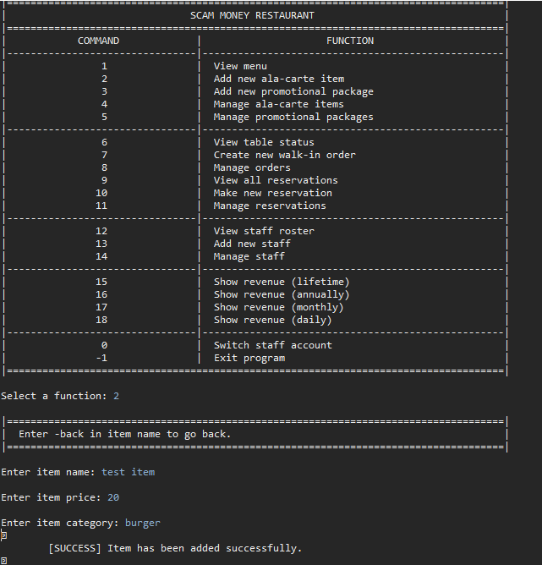

|  |  |  |  |  |  |  |  |  |  |  |
| --- | --- | --- | --- | --- | --- | --- | --- | --- | --- | --- |
| **Test Case ID** | | 02-1 | **Test Case Description** | | Invalid | | | | | |
|  |  |  |  |  |  |  |  |  |  |  |
|  |  |  |  |  |  |  |  |  |  |  |
| **Date Tested** | | 12-Apr-2019 | | **Test Case (Pass/Fail/Not Executed)** | | Pass | |
|  |  |  |  |  |  |  |  |  |  |  |
| **S #** | **Prerequisites:** | | |  |
| 1 | 02 | | |  |
| 2 |  | | |  |
| 3 |  | | |  |
| 4 |  | | |  |
|  |  |  |  |  |  |  |  |  |  |  |
| **Test Scenario** |  | | | | | |  |  |  |  |
|  |  |  |  |  |  |  |  |  |  |  |
| **Step #** | **Step Details** | | **Expected Results** | | **Actual Results** | | | **Pass / Fail / Not executed / Suspended** | | |
|
| 1 | Input unexpected value | | Error Message | | As expected | | | Pass | | |
|  |  | |  | |  | | |  | | |
|  |  | |  | |  | | |  | | |
|  |  | |  | |  | | |  | | |
|  |  | |  | |  | | |  | | |
|  |  | |  | |  | | |  | | |

|  |  |  |  |  |  |  |  |  |  |  |
| --- | --- | --- | --- | --- | --- | --- | --- | --- | --- | --- |
| **Test Case ID** | | 03 | **Test Case Description** | | Add new promotional package | | | | | |
|  |  |  |  |  |  |  |  |  |  |  |
|  |  |  |  |  |  |  |  |  |  |  |
| **Date Tested** | | 12-Apr-2019 | | **Test Case (Pass/Fail/Not Executed)** | | Pass | |
|  |  |  |  |  |  |  |  |  |  |  |
| **S #** | **Prerequisites:** | | |  |
| 1 | 00 | | |  |
| 2 |  | | |  |
| 3 |  | | |  |
| 4 |  | | |  |
|  |  |  |  |  |  |  |  |  |  |  |
| **Test Scenario** |  | | | | | |  |  |  |
|  |  |  |  |  |  |  |  |  |  |  |
| **Step #** | **Step Details** | | **Expected Results** | | **Actual Results** | | | **Pass / Fail / Not executed / Suspended** | | |
|
| 1 | Input ‘3’ | | Prompt to enter package name | | As expected | | | Pass | | |
| 2 | Input ‘Test Package’ | | Prompt to choose items | | As expected | | | Pass | | |
| 3 | Input ‘1’ | | Item added, Prompt to add another item or end | | As expected | | | Pass | | |
|  |  | |  | |  | | |  | | |
|  |  | |  | |  | | |  | | |
|  |  | |  | |  | | |  | | |

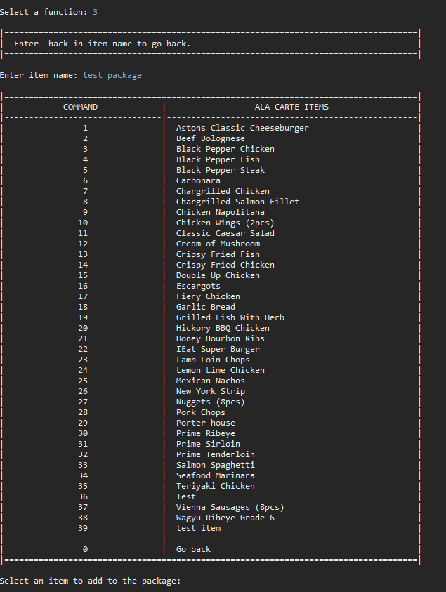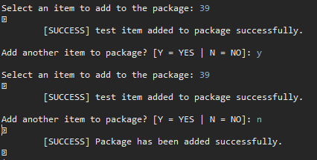

|  |  |  |  |  |  |  |  |  |  |  |
| --- | --- | --- | --- | --- | --- | --- | --- | --- | --- | --- |
| **Test Case ID** | | 03-1 | **Test Case Description** | | Add multiple items | | | | | |
|  |  |  |  |  |  |  |  |  |  |  |
|  |  |  |  |  |  |  |  |  |  |  |
| **Date Tested** | | 12-Apr-2019 | | **Test Case (Pass/Fail/Not Executed)** | | Pass | |
|  |  |  |  |  |  |  |  |  |  |  |
| **S #** | **Prerequisites:** | | |  |
| 1 | 03 | | |  |
| 2 |  | | |  |
| 3 |  | | |  |
| 4 |  | | |  |
|  |  |  |  |  |  |  |  |  |  |  |
| **Test Scenario** |  | | | | | |  |  |  |  |
|  |  |  |  |  |  |  |  |  |  |  |
| **Step #** | **Step Details** | | **Expected Results** | | **Actual Results** | | | **Pass / Fail / Not executed / Suspended** | | |
|
| 1 | Input ‘Y’ | | Prompt to add item | | As expected | | | Pass | | |
| 2 | Input ‘1’ | | Item added, Prompt to add another item or end | | As expected | | | Pass | | |
| 3 | Input ‘N’ | | Return to main Menu | | As expected | | | Pass | | |
| 4 | Input ‘1’ | | Item has been added | | As expected | | | Pass | | |
|  |  | |  | |  | | |  | | |
|  |  | |  | |  | | |  | | |

|  |  |  |  |  |  |  |  |  |  |  |
| --- | --- | --- | --- | --- | --- | --- | --- | --- | --- | --- |
| **Test Case ID** | | 03-2 | **Test Case Description** | | Add single item | | | | | |
|  |  |  |  |  |  |  |  |  |  |  |
|  |  |  |  |  |  |  |  |  |  |  |
| **Date Tested** | | 12-Apr-2019 | | **Test Case (Pass/Fail/Not Executed)** | | Pass | |
|  |  |  |  |  |  |  |  |  |  |  |
| **S #** | **Prerequisites:** | | |  |
| 1 | 03 | | |  |
| 2 |  | | |  |
| 3 |  | | |  |
| 4 |  | | |  |
|  |  |  |  |  |  |  |  |  |  |  |
| **Test Scenario** |  | | | | | |  |  |  |  |
|  |  |  |  |  |  |  |  |  |  |  |
| **Step #** | **Step Details** | | **Expected Results** | | **Actual Results** | | | **Pass / Fail / Not executed / Suspended** | | |
|
| 1 | Input ‘N’ | | Return to main menu | | As expected | | | Pass | | |
| 2 | Input ‘1’ | | Item has been added | | As expected | | | Pass | | |
|  |  | |  | |  | | |  | | |
|  |  | |  | |  | | |  | | |
|  |  | |  | |  | | |  | | |
|  |  | |  | |  | | |  | | |

|  |  |  |  |  |  |  |  |  |  |  |
| --- | --- | --- | --- | --- | --- | --- | --- | --- | --- | --- |
| **Test Case ID** | | 03-3 | **Test Case Description** | | Exit | | | | | |
|  |  |  |  |  |  |  |  |  |  |  |
|  |  |  |  |  |  |  |  |  |  |  |
| **Date Tested** | | 12-Apr-2019 | | **Test Case (Pass/Fail/Not Executed)** | | Pass | |
|  |  |  |  |  |  |  |  |  |  |  |
| **S #** | **Prerequisites:** | | |  |
| 1 | 03 | | |  |
| 2 |  | | |  |
| 3 |  | | |  |
| 4 |  | | |  |
|  |  |  |  |  |  |  |  |  |  |  |
| **Test Scenario** |  | | | | | |  |  |  |  |
|  |  |  |  |  |  |  |  |  |  |  |
| **Step #** | **Step Details** | | **Expected Results** | | **Actual Results** | | | **Pass / Fail / Not executed / Suspended** | | |
|
| 1 | Input ‘-back’ | | Return to main menu | | As expected | | | Pass | | |
|  |  | |  | |  | | |  | | |
|  |  | |  | |  | | |  | | |
|  |  | |  | |  | | |  | | |
|  |  | |  | |  | | |  | | |
|  |  | |  | |  | | |  | | |

|  |  |  |  |  |  |  |  |  |  |  |
| --- | --- | --- | --- | --- | --- | --- | --- | --- | --- | --- |
| **Test Case ID** | | 04 | **Test Case Description** | | Manage Ala Carte Item | | | | | |
|  |  |  |  |  |  |  |  |  |  |  |
|  |  |  |  |  |  |  |  |  |  |  |
| **Date Tested** | | 12-Apr-2019 | | **Test Case (Pass/Fail/Not Executed)** | | Pass | |
|  |  |  |  |  |  |  |  |  |  |  |
| **S #** | **Prerequisites:** | | |  |
| 1 | 00-1 | | |  |
| 2 |  | | |  |
| 3 |  | | |  |
| 4 |  | | |  |
|  |  |  |  |  |  |  |  |  |  |  |
| **Test Scenario** |  | | | | | |  |  |  |  |
|  |  |  |  |  |  |  |  |  |  |  |
| **Step #** | **Step Details** | | **Expected Results** | | **Actual Results** | | | **Pass / Fail / Not executed / Suspended** | | |
|
| 1 | Input ‘4’ | | View all items | | As expected | | | Pass | | |
| 2 | Input ‘1’ | | View management options | | As expected | | | Pass | | |
|  |  | |  | |  | | |  | | |
|  |  | |  | |  | | |  | | |
|  |  | |  | |  | | |  | | |
|  |  | |  | |  | | |  | | |

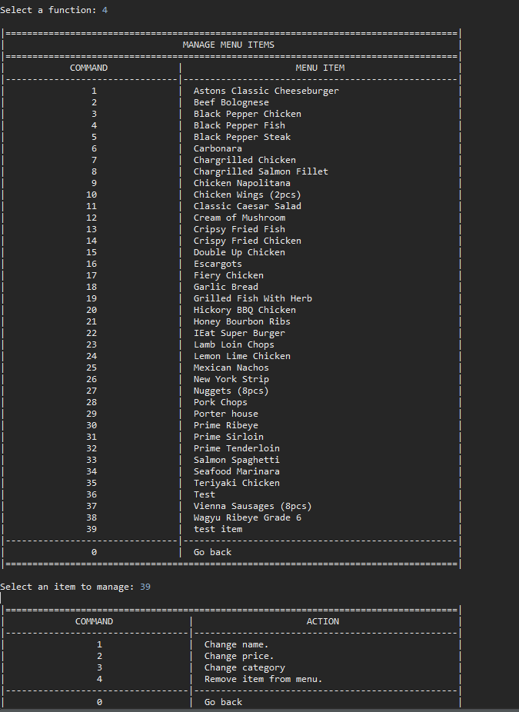

|  |  |  |  |  |  |  |  |  |  |  |
| --- | --- | --- | --- | --- | --- | --- | --- | --- | --- | --- |
| **Test Case ID** | | 04-1 | **Test Case Description** | | Change Name | | | | | |
|  |  |  |  |  |  |  |  |  |  |  |
|  |  |  |  |  |  |  |  |  |  |  |
| **Date Tested** | | 12-Apr-2019 | | **Test Case (Pass/Fail/Not Executed)** | | Pass | |
|  |  |  |  |  |  |  |  |  |  |  |
| **S #** | **Prerequisites:** | | |  |
| 1 | 04 | | |  |
| 2 |  | | |  |
| 3 |  | | |  |
| 4 |  | | |  |
|  |  |  |  |  |  |  |  |  |  |  |
| **Test Scenario** |  | | | | | |  |  |  |  |
|  |  |  |  |  |  |  |  |  |  |  |
| **Step #** | **Step Details** | | **Expected Results** | | **Actual Results** | | | **Pass / Fail / Not executed / Suspended** | | |
|
| 1 | Input ‘1’ | | Prompt for new name | | As expected | | | Pass | | |
| 2 | Input ‘TestChange’ | | Return to main menu | | As expected | | | Pass | | |
| 3 | Input ‘1’ | | Name has changed | | As expected | | | Pass | | |
|  |  | |  | |  | | |  | | |
|  |  | |  | |  | | |  | | |
|  |  | |  | |  | | |  | | |

|  |  |  |  |  |  |  |  |  |  |  |
| --- | --- | --- | --- | --- | --- | --- | --- | --- | --- | --- |
| **Test Case ID** | | 04-1-1 | **Test Case Description** | | Exit Menu | | | | | |
|  |  |  |  |  |  |  |  |  |  |  |
|  |  |  |  |  |  |  |  |  |  |  |
| **Date Tested** | | 12-Apr-2019 | | **Test Case (Pass/Fail/Not Executed)** | | Pass | |
|  |  |  |  |  |  |  |  |  |  |  |
| **S #** | **Prerequisites:** | | |  |
| 1 | 04-1 | | |  |
| 2 |  | | |  |
| 3 |  | | |  |
| 4 |  | | |  |
|  |  |  |  |  |  |  |  |  |  |  |
| **Test Scenario** |  | | | | | |  |  |  |  |
|  |  |  |  |  |  |  |  |  |  |  |
| **Step #** | **Step Details** | | **Expected Results** | | **Actual Results** | | | **Pass / Fail / Not executed / Suspended** | | |
|
| 1 | Input ‘-back’ | | Return to main menu | | As expected | | | Pass | | |
|  |  | |  | |  | | |  | | |
|  |  | |  | |  | | |  | | |
|  |  | |  | |  | | |  | | |
|  |  | |  | |  | | |  | | |
|  |  | |  | |  | | |  | | |

|  |  |  |  |  |  |  |  |  |  |  |
| --- | --- | --- | --- | --- | --- | --- | --- | --- | --- | --- |
| **Test Case ID** | | 04-2 | **Test Case Description** | | Change price | | | | | |
|  |  |  |  |  |  |  |  |  |  |  |
|  |  |  |  |  |  |  |  |  |  |  |
| **Date Tested** | | 12-Apr-2019 | | **Test Case (Pass/Fail/Not Executed)** | | Pass | |
|  |  |  |  |  |  |  |  |  |  |  |
| **S #** | **Prerequisites:** | | |  |
| 1 | 04 | | |  |
| 2 |  | | |  |
| 3 |  | | |  |
| 4 |  | | |  |
|  |  |  |  |  |  |  |  |  |  |  |
| **Test Scenario** |  | | | | | |  |  |  |  |
|  |  |  |  |  |  |  |  |  |  |  |
| **Step #** | **Step Details** | | **Expected Results** | | **Actual Results** | | | **Pass / Fail / Not executed / Suspended** | | |
|
| 1 | Input ‘1’ | | Prompt to enter price | | As expected | | | Pass | | |
| 2 | Input ’20.50‘ | | Return to main menu | | As expected | | | Pass | | |
| 3 | Input ‘1’ | | Item price has changed | | As expected | | | Pass | | |
|  |  | |  | |  | | |  | | |
|  |  | |  | |  | | |  | | |
|  |  | |  | |  | | |  | | |

|  |  |  |  |  |  |  |  |  |  |  |
| --- | --- | --- | --- | --- | --- | --- | --- | --- | --- | --- |
| **Test Case ID** | | 04-2-1 | **Test Case Description** | | Invalid | | | | | |
|  |  |  |  |  |  |  |  |  |  |  |
|  |  |  |  |  |  |  |  |  |  |  |
| **Date Tested** | | 12-Apr-2019 | | **Test Case (Pass/Fail/Not Executed)** | | Pass | |
|  |  |  |  |  |  |  |  |  |  |  |
| **S #** | **Prerequisites:** | | |  |
| 1 | 04-2 | | |  |
| 2 |  | | |  |
| 3 |  | | |  |
| 4 |  | | |  |
|  |  |  |  |  |  |  |  |  |  |  |
| **Test Scenario** |  | | | | | |  |  |  |  |
|  |  |  |  |  |  |  |  |  |  |  |
| **Step #** | **Step Details** | | **Expected Results** | | **Actual Results** | | | **Pass / Fail / Not executed / Suspended** | | |
|
| 1 | Input ‘asd’ | | Error message | | As expected | | | Pass | | |
|  |  | |  | |  | | |  | | |
|  |  | |  | |  | | |  | | |
|  |  | |  | |  | | |  | | |
|  |  | |  | |  | | |  | | |
|  |  | |  | |  | | |  | | |

|  |  |  |  |  |  |  |  |  |  |  |
| --- | --- | --- | --- | --- | --- | --- | --- | --- | --- | --- |
| **Test Case ID** | | 04-3 | **Test Case Description** | | Change Category | | | | | |
|  |  |  |  |  |  |  |  |  |  |  |
|  |  |  |  |  |  |  |  |  |  |  |
| **Date Tested** | | 12-Apr-2019 | | **Test Case (Pass/Fail/Not Executed)** | | Pass | |
|  |  |  |  |  |  |  |  |  |  |  |
| **S #** | **Prerequisites:** | | |  |
| 1 |  | | |  |
| 2 |  | | |  |
| 3 |  | | |  |
| 4 |  | | |  |
|  |  |  |  |  |  |  |  |  |  |  |
| **Test Scenario** |  | | | | | |  |  |  |  |
|  |  |  |  |  |  |  |  |  |  |  |
| **Step #** | **Step Details** | | **Expected Results** | | **Actual Results** | | | **Pass / Fail / Not executed / Suspended** | | |
|
| 1 | Input ‘Test’ | | Return to main menu | | As expected | | | Pass | | |
| 2 | Input ‘1’ | | Item category changed | | As expected | | | Pass | | |
|  |  | |  | |  | | |  | | |
|  |  | |  | |  | | |  | | |
|  |  | |  | |  | | |  | | |
|  |  | |  | |  | | |  | | |

|  |  |  |  |  |  |  |  |  |  |  |
| --- | --- | --- | --- | --- | --- | --- | --- | --- | --- | --- |
| **Test Case ID** | | 04-3-1 | **Test Case Description** | | Exit | | | | | |
|  |  |  |  |  |  |  |  |  |  |  |
|  |  |  |  |  |  |  |  |  |  |  |
| **Date Tested** | | 12-Apr-2019 | | **Test Case (Pass/Fail/Not Executed)** | | Pass | |
|  |  |  |  |  |  |  |  |  |  |  |
| **S #** | **Prerequisites:** | | |  |
| 1 | 04-3 | | |  |
| 2 |  | | |  |
| 3 |  | | |  |
| 4 |  | | |  |
|  |  |  |  |  |  |  |  |  |  |  |
| **Test Scenario** |  | | | | | |  |  |  |  |
|  |  |  |  |  |  |  |  |  |  |  |
| **Step #** | **Step Details** | | **Expected Results** | | **Actual Results** | | | **Pass / Fail / Not executed / Suspended** | | |
|
| 1 | Input ‘-back’ | | Return to main menu | | As expected | | | Pass | | |
|  |  | |  | |  | | |  | | |
|  |  | |  | |  | | |  | | |
|  |  | |  | |  | | |  | | |
|  |  | |  | |  | | |  | | |
|  |  | |  | |  | | |  | | |

|  |  |  |  |  |  |  |  |  |  |  |
| --- | --- | --- | --- | --- | --- | --- | --- | --- | --- | --- |
| **Test Case ID** | | 04-4 | **Test Case Description** | | Remove | | | | | |
|  |  |  |  |  |  |  |  |  |  |  |
|  |  |  |  |  |  |  |  |  |  |  |
| **Date Tested** | | 12-Apr-2019 | | **Test Case (Pass/Fail/Not Executed)** | | Pass | |
|  |  |  |  |  |  |  |  |  |  |  |
| **S #** | **Prerequisites:** | | |  |
| 1 | 04 | | |  |
| 2 |  | | |  |
| 3 |  | | |  |
| 4 |  | | |  |
|  |  |  |  |  |  |  |  |  |  |  |
| **Test Scenario** |  | | | | | |  |  |  |  |
|  |  |  |  |  |  |  |  |  |  |  |
| **Step #** | **Step Details** | | **Expected Results** | | **Actual Results** | | | **Pass / Fail / Not executed / Suspended** | | |
|
| 1 | Input ‘4’ | | Prompt to remove Item | | As expected | | | Pass | | |
|  |  | |  | |  | | |  | | |
|  |  | |  | |  | | |  | | |
|  |  | |  | |  | | |  | | |
|  |  | |  | |  | | |  | | |
|  |  | |  | |  | | |  | | |

|  |  |  |  |  |  |  |  |  |  |  |
| --- | --- | --- | --- | --- | --- | --- | --- | --- | --- | --- |
| **Test Case ID** | | 04-4-1 | **Test Case Description** | | Yes | | | | | |
|  |  |  |  |  |  |  |  |  |  |  |
|  |  |  |  |  |  |  |  |  |  |  |
| **Date Tested** | | 12-Apr-2019 | | **Test Case (Pass/Fail/Not Executed)** | | Pass | |
|  |  |  |  |  |  |  |  |  |  |  |
| **S #** | **Prerequisites:** | | |  |
| 1 | 04-4 | | |  |
| 2 |  | | |  |
| 3 |  | | |  |
| 4 |  | | |  |
|  |  |  |  |  |  |  |  |  |  |  |
| **Test Scenario** |  | | | | | |  |  |  |  |
|  |  |  |  |  |  |  |  |  |  |  |
| **Step #** | **Step Details** | | **Expected Results** | | **Actual Results** | | | **Pass / Fail / Not executed / Suspended** | | |
|
| 1 | Input ‘Y’ | | Return to main menu | | As expected | | | Pass | | |
| 2 | Input ‘1’ | | Item has been added | | As expected | | | Pass | | |
|  |  | |  | |  | | |  | | |
|  |  | |  | |  | | |  | | |
|  |  | |  | |  | | |  | | |
|  |  | |  | |  | | |  | | |

|  |  |  |  |  |  |  |  |  |  |  |
| --- | --- | --- | --- | --- | --- | --- | --- | --- | --- | --- |
| **Test Case ID** | | 04-4-2 | **Test Case Description** | | No | | | | | |
|  |  |  |  |  |  |  |  |  |  |  |
|  |  |  |  |  |  |  |  |  |  |  |
| **Date Tested** | | 12-Apr-2019 | | **Test Case (Pass/Fail/Not Executed)** | | Pass | |
|  |  |  |  |  |  |  |  |  |  |  |
| **S #** | **Prerequisites:** | | |  |
| 1 | 04-4 | | |  |
| 2 |  | | |  |
| 3 |  | | |  |
| 4 |  | | |  |
|  |  |  |  |  |  |  |  |  |  |  |
| **Test Scenario** |  | | | | | |  |  |  |  |
|  |  |  |  |  |  |  |  |  |  |  |
| **Step #** | **Step Details** | | **Expected Results** | | **Actual Results** | | | **Pass / Fail / Not executed / Suspended** | | |
|
| 1 | Input ‘N’ | | Return to main menu | | As expected | | | Pass | | |
| 2 | Input ‘1’ | | Item has been removed | | As expected | | | Pass | | |
|  |  | |  | |  | | |  | | |
|  |  | |  | |  | | |  | | |
|  |  | |  | |  | | |  | | |
|  |  | |  | |  | | |  | | |

|  |  |  |  |  |  |  |  |  |  |  |
| --- | --- | --- | --- | --- | --- | --- | --- | --- | --- | --- |
| **Test Case ID** | | 04-4-3 | **Test Case Description** | | Invalid | | | | | |
|  |  |  |  |  |  |  |  |  |  |  |
|  |  |  |  |  |  |  |  |  |  |  |
| **Date Tested** | | 12-Apr-2019 | | **Test Case (Pass/Fail/Not Executed)** | | Pass | |
|  |  |  |  |  |  |  |  |  |  |  |
| **S #** | **Prerequisites:** | | |  |
| 1 | 04-4 | | |  |
| 2 |  | | |  |
| 3 |  | | |  |
| 4 |  | | |  |
|  |  |  |  |  |  |  |  |  |  |  |
| **Test Scenario** |  | | | | | |  |  |  |  |
|  |  |  |  |  |  |  |  |  |  |  |
| **Step #** | **Step Details** | | **Expected Results** | | **Actual Results** | | | **Pass / Fail / Not executed / Suspended** | | |
|
| 1 | Input unexpected value | | Error Message | | As expected | | | Pass | | |
|  |  | |  | |  | | |  | | |
|  |  | |  | |  | | |  | | |
|  |  | |  | |  | | |  | | |
|  |  | |  | |  | | |  | | |
|  |  | |  | |  | | |  | | |

|  |  |  |  |  |  |  |  |  |  |  |
| --- | --- | --- | --- | --- | --- | --- | --- | --- | --- | --- |
| **Test Case ID** | | 04-5 | **Test Case Description** | | Exit | | | | | |
|  |  |  |  |  |  |  |  |  |  |  |
|  |  |  |  |  |  |  |  |  |  |  |
| **Date Tested** | | 12-Apr-2019 | | **Test Case (Pass/Fail/Not Executed)** | | Pass | |
|  |  |  |  |  |  |  |  |  |  |  |
| **S #** | **Prerequisites:** | | |  |
| 1 | 04 | | |  |
| 2 |  | | |  |
| 3 |  | | |  |
| 4 |  | | |  |
|  |  |  |  |  |  |  |  |  |  |  |
| **Test Scenario** |  | | | | | |  |  |  |  |
|  |  |  |  |  |  |  |  |  |  |  |
| **Step #** | **Step Details** | | **Expected Results** | | **Actual Results** | | | **Pass / Fail / Not executed / Suspended** | | |
|
| 1 | Input ‘0’ | | Return to main menu | | As expected | | | Pass | | |
|  |  | |  | |  | | |  | | |
|  |  | |  | |  | | |  | | |
|  |  | |  | |  | | |  | | |
|  |  | |  | |  | | |  | | |
|  |  | |  | |  | | |  | | |

|  |  |  |  |  |  |  |  |  |  |  |
| --- | --- | --- | --- | --- | --- | --- | --- | --- | --- | --- |
| **Test Case ID** | | 04-6 | **Test Case Description** | | Invalid | | | | | |
|  |  |  |  |  |  |  |  |  |  |  |
|  |  |  |  |  |  |  |  |  |  |  |
| **Date Tested** | | 12-Apr-2019 | | **Test Case (Pass/Fail/Not Executed)** | | Pass | |
|  |  |  |  |  |  |  |  |  |  |  |
| **S #** | **Prerequisites:** | | |  |
| 1 | 04 | | |  |
| 2 |  | | |  |
| 3 |  | | |  |
| 4 |  | | |  |
|  |  |  |  |  |  |  |  |  |  |  |
| **Test Scenario** |  | | | | | |  |  |  |  |
|  |  |  |  |  |  |  |  |  |  |  |
| **Step #** | **Step Details** | | **Expected Results** | | **Actual Results** | | | **Pass / Fail / Not executed / Suspended** | | |
|
| 1 | Input unexpected value | | Error message | | As expected | | | Pass | | |
|  |  | |  | |  | | |  | | |
|  |  | |  | |  | | |  | | |
|  |  | |  | |  | | |  | | |
|  |  | |  | |  | | |  | | |
|  |  | |  | |  | | |  | | |

|  |  |  |  |  |  |  |  |  |  |  |
| --- | --- | --- | --- | --- | --- | --- | --- | --- | --- | --- |
| **Test Case ID** | | 05 | **Test Case Description** | | Manage promo items | | | | | |
|  |  |  |  |  |  |  |  |  |  |  |
|  |  |  |  |  |  |  |  |  |  |  |
| **Date Tested** | | 12-Apr-2019 | | **Test Case (Pass/Fail/Not Executed)** | | Pass | |
|  |  |  |  |  |  |  |  |  |  |  |
| **S #** | **Prerequisites:** | | |  |
| 1 | 00-1 | | |  |
| 2 |  | | |  |
| 3 |  | | |  |
| 4 |  | | |  |
|  |  |  |  |  |  |  |  |  |  |  |
| **Test Scenario** |  | | | | | |  |  |  |  |
|  |  |  |  |  |  |  |  |  |  |  |
| **Step #** | **Step Details** | | **Expected Results** | | **Actual Results** | | | **Pass / Fail / Not executed / Suspended** | | |
|
| 1 | Input ‘5’ | | Prompt to choose item | | As expected | | | Pass | | |
| 2 | Input ‘1’ | | Prompt to choose management option | | As expected | | | Pass | | |
|  |  | |  | |  | | |  | | |
|  |  | |  | |  | | |  | | |
|  |  | |  | |  | | |  | | |
|  |  | |  | |  | | |  | | |

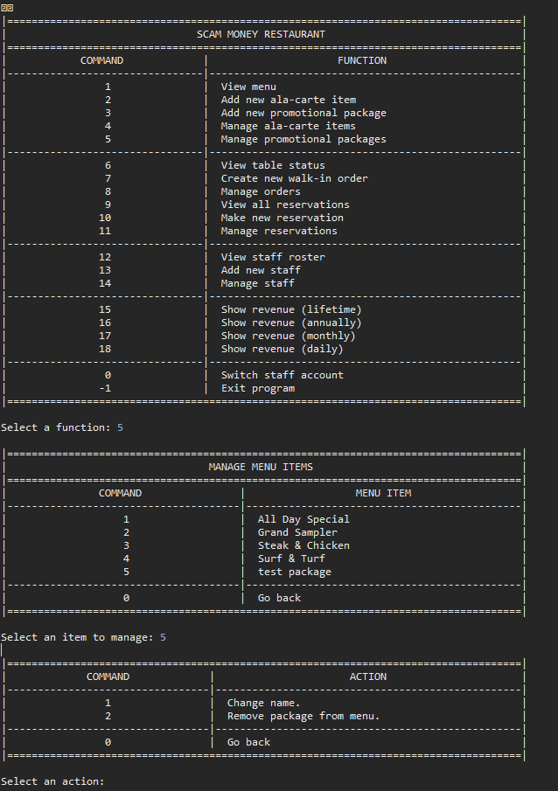

|  |  |  |  |  |  |  |  |  |  |  |
| --- | --- | --- | --- | --- | --- | --- | --- | --- | --- | --- |
| **Test Case ID** | | 05-1 | **Test Case Description** | | Change Name | | | | | |
|  |  |  |  |  |  |  |  |  |  |  |
|  |  |  |  |  |  |  |  |  |  |  |
| **Date Tested** | | 12-Apr-2019 | | **Test Case (Pass/Fail/Not Executed)** | | Pass | |
|  |  |  |  |  |  |  |  |  |  |  |
| **S #** | **Prerequisites:** | | |  |
| 1 | 05 | | |  |
| 2 |  | | |  |
| 3 |  | | |  |
| 4 |  | | |  |
|  |  |  |  |  |  |  |  |  |  |  |
| **Test Scenario** |  | | | | | |  |  |  |  |
|  |  |  |  |  |  |  |  |  |  |  |
| **Step #** | **Step Details** | | **Expected Results** | | **Actual Results** | | | **Pass / Fail / Not executed / Suspended** | | |
|
| 1 | Input ‘1’ | | Prompt to input name | | As expected | | | Pass | | |
| 2 | Input ‘Test’ | | Return to main menu | | As expected | | | Pass | | |
| 3 | Input ‘1’ | | Item name has been changed | | AS expected | | | Pass | | |
|  |  | |  | |  | | |  | | |
|  |  | |  | |  | | |  | | |
|  |  | |  | |  | | |  | | |

|  |  |  |  |  |  |  |  |  |  |  |
| --- | --- | --- | --- | --- | --- | --- | --- | --- | --- | --- |
| **Test Case ID** | | 05-2 | **Test Case Description** | | Remove | | | | | |
|  |  |  |  |  |  |  |  |  |  |  |
|  |  |  |  |  |  |  |  |  |  |  |
| **Date Tested** | | 12-Apr-2019 | | **Test Case (Pass/Fail/Not Executed)** | | Pas | |
|  |  |  |  |  |  |  |  |  |  |  |
| **S #** | **Prerequisites:** | | |  |
| 1 | 05 | | |  |
| 2 |  | | |  |
| 3 |  | | |  |
| 4 |  | | |  |
|  |  |  |  |  |  |  |  |  |  |  |
| **Test Scenario** |  | | | | | |  |  |  |  |
|  |  |  |  |  |  |  |  |  |  |  |
| **Step #** | **Step Details** | | **Expected Results** | | **Actual Results** | | | **Pass / Fail / Not executed / Suspended** | | |
|
| 1 | Input ‘2’ | | Prompt to confirm | | As expected | | | Pas | | |
|  |  | |  | |  | | |  | | |
|  |  | |  | |  | | |  | | |
|  |  | |  | |  | | |  | | |
|  |  | |  | |  | | |  | | |
|  |  | |  | |  | | |  | | |

|  |  |  |  |  |  |  |  |  |  |  |
| --- | --- | --- | --- | --- | --- | --- | --- | --- | --- | --- |
| **Test Case ID** | | 05-2-1 | **Test Case Description** | | Yes | | | | | |
|  |  |  |  |  |  |  |  |  |  |  |
|  |  |  |  |  |  |  |  |  |  |  |
| **Date Tested** | | 12-Apr-2019 | | **Test Case (Pass/Fail/Not Executed)** | | Pass | |
|  |  |  |  |  |  |  |  |  |  |  |
| **S #** | **Prerequisites:** | | |  |
| 1 | 05-2 | | |  |
| 2 |  | | |  |
| 3 |  | | |  |
| 4 |  | | |  |
|  |  |  |  |  |  |  |  |  |  |  |
| **Test Scenario** |  | | | | | |  |  |  |  |
|  |  |  |  |  |  |  |  |  |  |  |
| **Step #** | **Step Details** | | **Expected Results** | | **Actual Results** | | | **Pass / Fail / Not executed / Suspended** | | |
|
| 1 | Input ‘Y’ | | Return to main menu | | As expected | | | Pass | | |
| 2 | Input ‘ 1’ | | Item has been removed | | As expected | | | Pass | | |
|  |  | |  | |  | | |  | | |
|  |  | |  | |  | | |  | | |
|  |  | |  | |  | | |  | | |
|  |  | |  | |  | | |  | | |

|  |  |  |  |  |  |  |  |  |  |  |
| --- | --- | --- | --- | --- | --- | --- | --- | --- | --- | --- |
| **Test Case ID** | | 05-2-2 | **Test Case Description** | | No | | | | | |
|  |  |  |  |  |  |  |  |  |  |  |
|  |  |  |  |  |  |  |  |  |  |  |
| **Date Tested** | | 12-Apr-2019 | | **Test Case (Pass/Fail/Not Executed)** | | Pass | |
|  |  |  |  |  |  |  |  |  |  |  |
| **S #** | **Prerequisites:** | | |  |
| 1 | 05-2 | | |  |
| 2 |  | | |  |
| 3 |  | | |  |
| 4 |  | | |  |
|  |  |  |  |  |  |  |  |  |  |  |
| **Test Scenario** |  | | | | | |  |  |  |  |
|  |  |  |  |  |  |  |  |  |  |  |
| **Step #** | **Step Details** | | **Expected Results** | | **Actual Results** | | | **Pass / Fail / Not executed / Suspended** | | |
|
| 1 | Input ‘N’ | | Return to main menu | | As expected | | | Pass | | |
|  |  | |  | |  | | |  | | |
|  |  | |  | |  | | |  | | |
|  |  | |  | |  | | |  | | |
|  |  | |  | |  | | |  | | |
|  |  | |  | |  | | |  | | |

|  |  |  |  |  |  |  |  |  |  |  |
| --- | --- | --- | --- | --- | --- | --- | --- | --- | --- | --- |
| **Test Case ID** | | 05-2-3 | **Test Case Description** | | Invalid | | | | | |
|  |  |  |  |  |  |  |  |  |  |  |
|  |  |  |  |  |  |  |  |  |  |  |
| **Date Tested** | | 12-Apr-2019 | | **Test Case (Pass/Fail/Not Executed)** | | Pass | |
|  |  |  |  |  |  |  |  |  |  |  |
| **S #** | **Prerequisites:** | | |  |
| 1 | 05-2 | | |  |
| 2 |  | | |  |
| 3 |  | | |  |
| 4 |  | | |  |
|  |  |  |  |  |  |  |  |  |  |  |
| **Test Scenario** |  | | | | | |  |  |  |  |
|  |  |  |  |  |  |  |  |  |  |  |
| **Step #** | **Step Details** | | **Expected Results** | | **Actual Results** | | | **Pass / Fail / Not executed / Suspended** | | |
|
| 1 | Input unexpected value | | Error message | | As expected | | | Pass | | |
|  |  | |  | |  | | |  | | |
|  |  | |  | |  | | |  | | |
|  |  | |  | |  | | |  | | |
|  |  | |  | |  | | |  | | |
|  |  | |  | |  | | |  | | |

|  |  |  |  |  |  |  |  |  |  |  |
| --- | --- | --- | --- | --- | --- | --- | --- | --- | --- | --- |
| **Test Case ID** | | 06 | **Test Case Description** | | View tables | | | | | |
|  |  |  |  |  |  |  |  |  |  |  |
|  |  |  |  |  |  |  |  |  |  |  |
| **Date Tested** | | 12-Apr-2019 | | **Test Case (Pass/Fail/Not Executed)** | | Pass | |
|  |  |  |  |  |  |  |  |  |  |  |
| **S #** | **Prerequisites:** | | |  |
| 1 | 00-1 | | |  |
| 2 |  | | |  |
| 3 |  | | |  |
| 4 |  | | |  |
|  |  |  |  |  |  |  |  |  |  |  |
| **Test Scenario** |  | | | | | |  |  |  |  |
|  |  |  |  |  |  |  |  |  |  |  |
| **Step #** | **Step Details** | | **Expected Results** | | **Actual Results** | | | **Pass / Fail / Not executed / Suspended** | | |
|
| 1 | Input ‘6’ | | Table status is shown | | As expected | | | Pass | | |
|  |  | |  | |  | | |  | | |
|  |  | |  | |  | | |  | | |
|  |  | |  | |  | | |  | | |
|  |  | |  | |  | | |  | | |
|  |  | |  | |  | | |  | | |

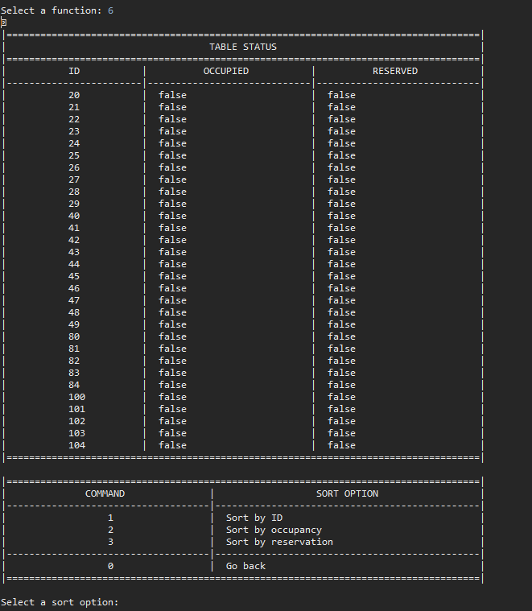

|  |  |  |  |  |  |  |  |  |  |  |
| --- | --- | --- | --- | --- | --- | --- | --- | --- | --- | --- |
| **Test Case ID** | | 06-1 | **Test Case Description** | | Sort by ID | | | | | |
|  |  |  |  |  |  |  |  |  |  |  |
|  |  |  |  |  |  |  |  |  |  |  |
| **Date Tested** | | 12-Apr-2019 | | **Test Case (Pass/Fail/Not Executed)** | |  | |
|  |  |  |  |  |  |  |  |  |  |  |
| **S #** | **Prerequisites:** | | |  |
| 1 | 06 | | |  |
| 2 |  | | |  |
| 3 |  | | |  |
| 4 |  | | |  |
|  |  |  |  |  |  |  |  |  |  |  |
| **Test Scenario** |  | | | | | |  |  |  |  |
|  |  |  |  |  |  |  |  |  |  |  |
| **Step #** | **Step Details** | | **Expected Results** | | **Actual Results** | | | **Pass / Fail / Not executed / Suspended** | | |
|
| 1 | Input ‘1’ | | List is sorted | | As expected | | | Pass | | |
|  |  | |  | |  | | |  | | |
|  |  | |  | |  | | |  | | |
|  |  | |  | |  | | |  | | |
|  |  | |  | |  | | |  | | |
|  |  | |  | |  | | |  | | |

|  |  |  |  |  |  |  |  |  |  |  |
| --- | --- | --- | --- | --- | --- | --- | --- | --- | --- | --- |
| **Test Case ID** | | 06-2 | **Test Case Description** | | Sort by occupancy | | | | | |
|  |  |  |  |  |  |  |  |  |  |  |
|  |  |  |  |  |  |  |  |  |  |  |
| **Date Tested** | | 12-Apr-2019 | | **Test Case (Pass/Fail/Not Executed)** | | Pass | |
|  |  |  |  |  |  |  |  |  |  |  |
| **S #** | **Prerequisites:** | | |  |
| 1 | 06 | | |  |
| 2 | At least one occupied table | | |  |
| 3 |  | | |  |
| 4 |  | | |  |
|  |  |  |  |  |  |  |  |  |  |  |
| **Test Scenario** |  | | | | | |  |  |  |  |
|  |  |  |  |  |  |  |  |  |  |  |
| **Step #** | **Step Details** | | **Expected Results** | | **Actual Results** | | | **Pass / Fail / Not executed / Suspended** | | |
|
| 1 | Input ‘2’ | | List is sorted | | As expected | | | Pass | | |
|  |  | |  | |  | | |  | | |
|  |  | |  | |  | | |  | | |
|  |  | |  | |  | | |  | | |
|  |  | |  | |  | | |  | | |
|  |  | |  | |  | | |  | | |

|  |  |  |  |  |  |  |  |  |  |  |
| --- | --- | --- | --- | --- | --- | --- | --- | --- | --- | --- |
| **Test Case ID** | | 06-1 | **Test Case Description** | | Sort by reservation | | | | | |
|  |  |  |  |  |  |  |  |  |  |  |
|  |  |  |  |  |  |  |  |  |  |  |
| **Date Tested** | | 12-Apr-2019 | | **Test Case (Pass/Fail/Not Executed)** | | Pass | |
|  |  |  |  |  |  |  |  |  |  |  |
| **S #** | **Prerequisites:** | | |  |
| 1 | 06 | | |  |
| 2 | At least one reserved table | | |  |
| 3 |  | | |  |
| 4 |  | | |  |
|  |  |  |  |  |  |  |  |  |  |  |
| **Test Scenario** |  | | | | | |  |  |  |  |
|  |  |  |  |  |  |  |  |  |  |  |
| **Step #** | **Step Details** | | **Expected Results** | | **Actual Results** | | | **Pass / Fail / Not executed / Suspended** | | |
|
| 1 | Input ‘3’ | | List is sorted | | As expected | | | Pass | | |
|  |  | |  | |  | | |  | | |
|  |  | |  | |  | | |  | | |
|  |  | |  | |  | | |  | | |
|  |  | |  | |  | | |  | | |
|  |  | |  | |  | | |  | | |

|  |  |  |  |  |  |  |  |  |  |  |
| --- | --- | --- | --- | --- | --- | --- | --- | --- | --- | --- |
| **Test Case ID** | | 06-4 | **Test Case Description** | | Exit | | | | | |
|  |  |  |  |  |  |  |  |  |  |  |
|  |  |  |  |  |  |  |  |  |  |  |
| **Date Tested** | | 12-Apr-2019 | | **Test Case (Pass/Fail/Not Executed)** | | Pass | |
|  |  |  |  |  |  |  |  |  |  |  |
| **S #** | **Prerequisites:** | | |  |
| 1 | 06 | | |  |
| 2 |  | | |  |
| 3 |  | | |  |
| 4 |  | | |  |
|  |  |  |  |  |  |  |  |  |  |  |
| **Test Scenario** |  | | | | | |  |  |  |  |
|  |  |  |  |  |  |  |  |  |  |  |
| **Step #** | **Step Details** | | **Expected Results** | | **Actual Results** | | | **Pass / Fail / Not executed / Suspended** | | |
|
| 1 | Input ‘0 | | Return to main menu | | As expected | | | Pass | | |
|  |  | |  | |  | | |  | | |
|  |  | |  | |  | | |  | | |
|  |  | |  | |  | | |  | | |
|  |  | |  | |  | | |  | | |
|  |  | |  | |  | | |  | | |

|  |  |  |  |  |  |  |  |  |  |  |
| --- | --- | --- | --- | --- | --- | --- | --- | --- | --- | --- |
| **Test Case ID** | | 06-5 | **Test Case Description** | | Invalid | | | | | |
|  |  |  |  |  |  |  |  |  |  |  |
|  |  |  |  |  |  |  |  |  |  |  |
| **Date Tested** | | 12-Apr-2019 | | **Test Case (Pass/Fail/Not Executed)** | | Pass | |
|  |  |  |  |  |  |  |  |  |  |  |
| **S #** | **Prerequisites:** | | |  |
| 1 | 06 | | |  |
| 2 |  | | |  |
| 3 |  | | |  |
| 4 |  | | |  |
|  |  |  |  |  |  |  |  |  |  |  |
| **Test Scenario** |  | | | | | |  |  |  |  |
|  |  |  |  |  |  |  |  |  |  |  |
| **Step #** | **Step Details** | | **Expected Results** | | **Actual Results** | | | **Pass / Fail / Not executed / Suspended** | | |
|
| 1 | Input unexpected value | | Error message | | As expected | | | Pass | | |
|  |  | |  | |  | | |  | | |
|  |  | |  | |  | | |  | | |
|  |  | |  | |  | | |  | | |
|  |  | |  | |  | | |  | | |
|  |  | |  | |  | | |  | | |

|  |  |  |  |  |  |  |  |  |  |  |
| --- | --- | --- | --- | --- | --- | --- | --- | --- | --- | --- |
| **Test Case ID** | | 07 | **Test Case Description** | | New walk in order | | | | | |
|  |  |  |  |  |  |  |  |  |  |  |
|  |  |  |  |  |  |  |  |  |  |  |
| **Date Tested** | | 12-Apr-2019 | | **Test Case (Pass/Fail/Not Executed)** | | Pass | |
|  |  |  |  |  |  |  |  |  |  |  |
| **S #** | **Prerequisites:** | | |  |
| 1 | 00-1 | | |  |
| 2 |  | | |  |
| 3 |  | | |  |
| 4 |  | | |  |
|  |  |  |  |  |  |  |  |  |  |  |
| **Test Scenario** |  | | | | | |  |  |  |  |
|  |  |  |  |  |  |  |  |  |  |  |
| **Step #** | **Step Details** | | **Expected Results** | | **Actual Results** | | | **Pass / Fail / Not executed / Suspended** | | |
|
| 1 | Input ‘7’ | | Prompt to enter amt of pax | | As expected | | | Pass | | |
| 2 | Input ‘4’ | | Return to main menu | | As expected | | | Pass | | |
| 3 | Input ‘6’ | | Appropriate table is occupied | | As expected | | | Pass | | |
|  |  | |  | |  | | |  | | |
|  |  | |  | |  | | |  | | |
|  |  | |  | |  | | |  | | |

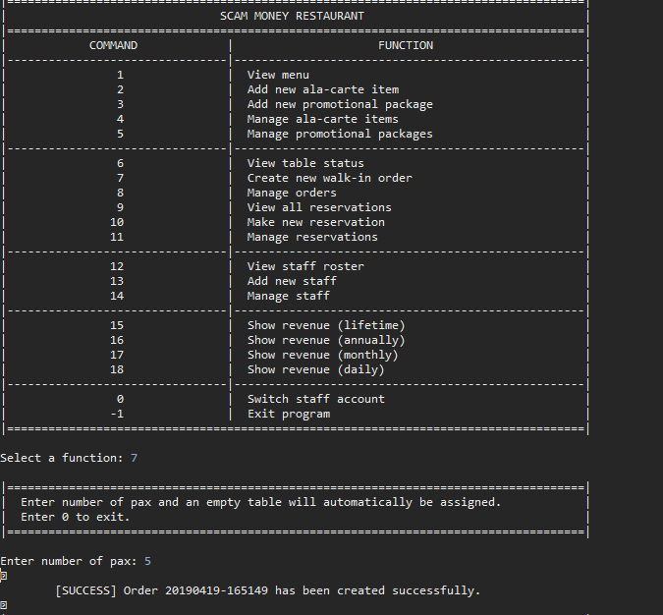

|  |  |  |  |  |  |  |  |  |  |  |
| --- | --- | --- | --- | --- | --- | --- | --- | --- | --- | --- |
| **Test Case ID** | | 07-1 | **Test Case Description** | | Too many pax | | | | | |
|  |  |  |  |  |  |  |  |  |  |  |
|  |  |  |  |  |  |  |  |  |  |  |
| **Date Tested** | | 12-Apr-2019 | | **Test Case (Pass/Fail/Not Executed)** | | Pass | |
|  |  |  |  |  |  |  |  |  |  |  |
| **S #** | **Prerequisites:** | | |  |
| 1 | 07.1 | | |  |
| 2 |  | | |  |
| 3 |  | | |  |
| 4 |  | | |  |
|  |  |  |  |  |  |  |  |  |  |  |
| **Test Scenario** |  | | | | | |  |  |  |  |
|  |  |  |  |  |  |  |  |  |  |  |
| **Step #** | **Step Details** | | **Expected Results** | | **Actual Results** | | | **Pass / Fail / Not executed / Suspended** | | |
|
| 1 | Input ‘12’ | | Error message | | As expected | | | Pass | | |
|  |  | |  | |  | | |  | | |
|  |  | |  | |  | | |  | | |
|  |  | |  | |  | | |  | | |
|  |  | |  | |  | | |  | | |
|  |  | |  | |  | | |  | | |

|  |  |  |  |  |  |  |  |  |  |  |
| --- | --- | --- | --- | --- | --- | --- | --- | --- | --- | --- |
| **Test Case ID** | | 07-2 | **Test Case Description** | | Tables full | | | | | |
|  |  |  |  |  |  |  |  |  |  |  |
|  |  |  |  |  |  |  |  |  |  |  |
| **Date Tested** | | 12-Apr-2019 | | **Test Case (Pass/Fail/Not Executed)** | | fail | |
|  |  |  |  |  |  |  |  |  |  |  |
| **S #** | **Prerequisites:** | | |  |
| 1 | 07.1 | | |  |
| 2 |  | | |  |
| 3 |  | | |  |
| 4 |  | | |  |
|  |  |  |  |  |  |  |  |  |  |  |
| **Test Scenario** |  | | | | | |  |  |  |  |
|  |  |  |  |  |  |  |  |  |  |  |
| **Step #** | **Step Details** | | **Expected Results** | | **Actual Results** | | | **Pass / Fail / Not executed / Suspended** | | |
|
| 1 | Input ‘4’ | | Error Message | | As expected | | | Pass | | |
|  |  | |  | |  | | |  | | |
|  |  | |  | |  | | |  | | |
|  |  | |  | |  | | |  | | |
|  |  | |  | |  | | |  | | |
|  |  | |  | |  | | |  | | |

|  |  |  |  |  |  |  |  |  |  |  |
| --- | --- | --- | --- | --- | --- | --- | --- | --- | --- | --- |
| **Test Case ID** | | 07-3 | **Test Case Description** | | Invalid | | | | | |
|  |  |  |  |  |  |  |  |  |  |  |
|  |  |  |  |  |  |  |  |  |  |  |
| **Date Tested** | | 12-Apr-2019 | | **Test Case (Pass/Fail/Not Executed)** | | Pass | |
|  |  |  |  |  |  |  |  |  |  |  |
| **S #** | **Prerequisites:** | | |  |
| 1 | 07.1 | | |  |
| 2 |  | | |  |
| 3 |  | | |  |
| 4 |  | | |  |
|  |  |  |  |  |  |  |  |  |  |  |
| **Test Scenario** |  | | | | | |  |  |  |  |
|  |  |  |  |  |  |  |  |  |  |  |
| **Step #** | **Step Details** | | **Expected Results** | | **Actual Results** | | | **Pass / Fail / Not executed / Suspended** | | |
|
| 1 | Input unexpected value | | Error message | | As expected | | | Pass | | |
|  |  | |  | |  | | |  | | |
|  |  | |  | |  | | |  | | |
|  |  | |  | |  | | |  | | |
|  |  | |  | |  | | |  | | |
|  |  | |  | |  | | |  | | |

|  |  |  |  |  |  |  |  |  |  |  |
| --- | --- | --- | --- | --- | --- | --- | --- | --- | --- | --- |
| **Test Case ID** | | 08 | **Test Case Description** | | Manage orders | | | | | |
|  |  |  |  |  |  |  |  |  |  |  |
|  |  |  |  |  |  |  |  |  |  |  |
| **Date Tested** | | 12-Apr-2019 | | **Test Case (Pass/Fail/Not Executed)** | | Pass | |
|  |  |  |  |  |  |  |  |  |  |  |
| **S #** | **Prerequisites:** | | |  |
| 1 | 00-1 | | |  |
| 2 | At least 1 open order | | |  |
| 3 |  | | |  |
| 4 |  | | |  |
|  |  |  |  |  |  |  |  |  |  |  |
| **Test Scenario** |  | | | | | |  |  |  |  |
|  |  |  |  |  |  |  |  |  |  |  |
| **Step #** | **Step Details** | | **Expected Results** | | **Actual Results** | | | **Pass / Fail / Not executed / Suspended** | | |
|
| 1 | Input ‘8’ | | Prompt to select order | | As expected | | | Pass | | |
| 2 | Input ‘1’ | | Prompt to manage order | | As expected | | | Pass | | |
|  |  | |  | |  | | |  | | |
|  |  | |  | |  | | |  | | |
|  |  | |  | |  | | |  | | |
|  |  | |  | |  | | |  | | |

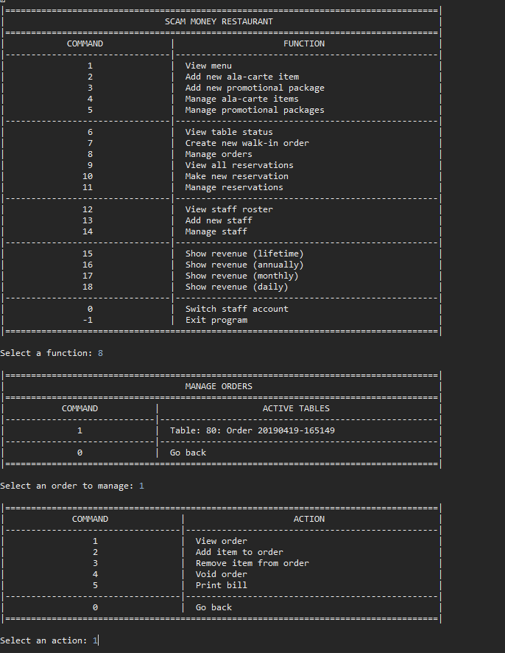

|  |  |  |  |  |  |  |  |  |  |  |
| --- | --- | --- | --- | --- | --- | --- | --- | --- | --- | --- |
| **Test Case ID** | | 08-1 | **Test Case Description** | | View | | | | | |
|  |  |  |  |  |  |  |  |  |  |  |
|  |  |  |  |  |  |  |  |  |  |  |
| **Date Tested** | | 12-Apr-2019 | | **Test Case (Pass/Fail/Not Executed)** | | Pass | |
|  |  |  |  |  |  |  |  |  |  |  |
| **S #** | **Prerequisites:** | | |  |
| 1 | 08 | | |  |
| 2 |  | | |  |
| 3 |  | | |  |
| 4 |  | | |  |
|  |  |  |  |  |  |  |  |  |  |  |
| **Test Scenario** |  | | | | | |  |  |  |  |
|  |  |  |  |  |  |  |  |  |  |  |
| **Step #** | **Step Details** | | **Expected Results** | | **Actual Results** | | | **Pass / Fail / Not executed / Suspended** | | |
|
| 1 | Input ‘1’ | | Input information is shown | | As expected | | | Pass | | |
| 2 | Input ‘0’ | | Return to previous | | As expected | | | Pass | | |
|  |  | |  | |  | | |  | | |
|  |  | |  | |  | | |  | | |
|  |  | |  | |  | | |  | | |
|  |  | |  | |  | | |  | | |

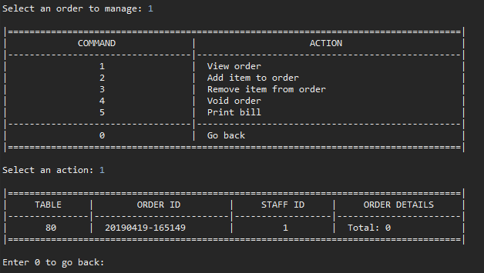

|  |  |  |  |  |  |  |  |  |  |  |
| --- | --- | --- | --- | --- | --- | --- | --- | --- | --- | --- |
| **Test Case ID** | | 08-2 | **Test Case Description** | | Add item | | | | | |
|  |  |  |  |  |  |  |  |  |  |  |
|  |  |  |  |  |  |  |  |  |  |  |
| **Date Tested** | | 12-Apr-2019 | | **Test Case (Pass/Fail/Not Executed)** | | Pass | |
|  |  |  |  |  |  |  |  |  |  |  |
| **S #** | **Prerequisites:** | | |  |
| 1 | 08 | | |  |
| 2 |  | | |  |
| 3 |  | | |  |
| 4 |  | | |  |
|  |  |  |  |  |  |  |  |  |  |  |
| **Test Scenario** |  | | | | | |  |  |  |  |
|  |  |  |  |  |  |  |  |  |  |  |
| **Step #** | **Step Details** | | **Expected Results** | | **Actual Results** | | | **Pass / Fail / Not executed / Suspended** | | |
|
| 1 | Input ‘2’ | | Prompt to choose item | | As expected | | | Pass | | |
| 2 | Input ‘1’ | | Prompt to enter amount | | As expected | | | Pass | | |
| 3 | Input ‘1’ | | Return to menu | | As expected | | | Pass | | |
| 4 | Input ‘1’ | | Order is shown | | As expected | | | Pass | | |
|  |  | |  | |  | | |  | | |
|  |  | |  | |  | | |  | | |

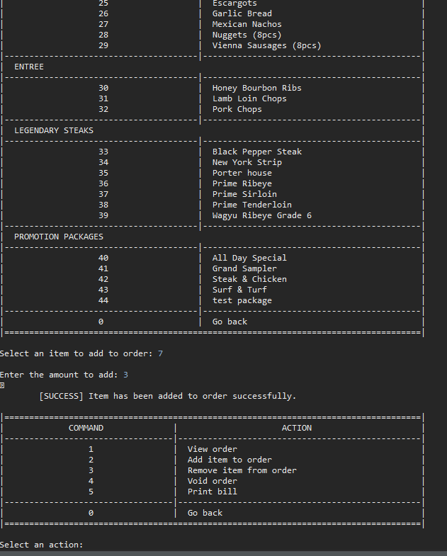

|  |  |  |  |  |  |  |  |  |  |  |
| --- | --- | --- | --- | --- | --- | --- | --- | --- | --- | --- |
| **Test Case ID** | | 08-02 | **Test Case Description** | | Invalid | | | | | |
|  |  |  |  |  |  |  |  |  |  |  |
|  |  |  |  |  |  |  |  |  |  |  |
| **Date Tested** | | 12-Apr-2019 | | **Test Case (Pass/Fail/Not Executed)** | | Pass | |
|  |  |  |  |  |  |  |  |  |  |  |
| **S #** | **Prerequisites:** | | |  |
| 1 | 08 | | |  |
| 2 |  | | |  |
| 3 |  | | |  |
| 4 |  | | |  |
|  |  |  |  |  |  |  |  |  |  |  |
| **Test Scenario** |  | | | | | |  |  |  |  |
|  |  |  |  |  |  |  |  |  |  |  |
| **Step #** | **Step Details** | | **Expected Results** | | **Actual Results** | | | **Pass / Fail / Not executed / Suspended** | | |
|
| 1 | Input unexpected value | | Error message | | As expected | | | Pass | | |
|  |  | |  | |  | | |  | | |
|  |  | |  | |  | | |  | | |
|  |  | |  | |  | | |  | | |
|  |  | |  | |  | | |  | | |
|  |  | |  | |  | | |  | | |

|  |  |  |  |  |  |  |  |  |  |  |
| --- | --- | --- | --- | --- | --- | --- | --- | --- | --- | --- |
| **Test Case ID** | | 08-4 | **Test Case Description** | | Void order | | | | | |
|  |  |  |  |  |  |  |  |  |  |  |
|  |  |  |  |  |  |  |  |  |  |  |
| **Date Tested** | | 12-Apr-2019 | | **Test Case (Pass/Fail/Not Executed)** | | Pass | |
|  |  |  |  |  |  |  |  |  |  |  |
| **S #** | **Prerequisites:** | | |  |
| 1 | 08 | | |  |
| 2 |  | | |  |
| 3 |  | | |  |
| 4 |  | | |  |
|  |  |  |  |  |  |  |  |  |  |  |
| **Test Scenario** |  | | | | | |  |  |  |  |
|  |  |  |  |  |  |  |  |  |  |  |
| **Step #** | **Step Details** | | **Expected Results** | | **Actual Results** | | | **Pass / Fail / Not executed / Suspended** | | |
|
| 1 | Input ‘4’ | | Confirmation message | | As expected | | | Pass | | |
|  |  | |  | |  | | |  | | |
|  |  | |  | |  | | |  | | |
|  |  | |  | |  | | |  | | |
|  |  | |  | |  | | |  | | |
|  |  | |  | |  | | |  | | |

|  |  |  |  |  |  |  |  |  |  |  |
| --- | --- | --- | --- | --- | --- | --- | --- | --- | --- | --- |
| **Test Case ID** | | 08-4-1 | **Test Case Description** | | Yes | | | | | |
|  |  |  |  |  |  |  |  |  |  |  |
|  |  |  |  |  |  |  |  |  |  |  |
| **Date Tested** | | 12-Apr-2019 | | **Test Case (Pass/Fail/Not Executed)** | | Pass | |
|  |  |  |  |  |  |  |  |  |  |  |
| **S #** | **Prerequisites:** | | |  |
| 1 | 08-4 | | |  |
| 2 |  | | |  |
| 3 |  | | |  |
| 4 |  | | |  |
|  |  |  |  |  |  |  |  |  |  |  |
| **Test Scenario** |  | | | | | |  |  |  |  |
|  |  |  |  |  |  |  |  |  |  |  |
| **Step #** | **Step Details** | | **Expected Results** | | **Actual Results** | | | **Pass / Fail / Not executed / Suspended** | | |
|
| 1 | Input ‘Y’ | | Return to main menu | | As expected | | | Pass | | |
| 2 | Input ‘8’ | | Order has been removed | | As expected | | | Pass | | |
|  |  | |  | |  | | |  | | |
|  |  | |  | |  | | |  | | |
|  |  | |  | |  | | |  | | |
|  |  | |  | |  | | |  | | |

|  |  |  |  |  |  |  |  |  |  |  |
| --- | --- | --- | --- | --- | --- | --- | --- | --- | --- | --- |
| **Test Case ID** | | 08-4-2 | **Test Case Description** | | No | | | | | |
|  |  |  |  |  |  |  |  |  |  |  |
|  |  |  |  |  |  |  |  |  |  |  |
| **Date Tested** | | 12-Apr-2019 | | **Test Case (Pass/Fail/Not Executed)** | | Pass | |
|  |  |  |  |  |  |  |  |  |  |  |
| **S #** | **Prerequisites:** | | |  |
| 1 | 08-4 | | |  |
| 2 |  | | |  |
| 3 |  | | |  |
| 4 |  | | |  |
|  |  |  |  |  |  |  |  |  |  |  |
| **Test Scenario** |  | | | | | |  |  |  |  |
|  |  |  |  |  |  |  |  |  |  |  |
| **Step #** | **Step Details** | | **Expected Results** | | **Actual Results** | | | **Pass / Fail / Not executed / Suspended** | | |
|
| 1 | Input ‘N’ | | Return to main menu | | As expected | | | Pass | | |
|  |  | |  | |  | | |  | | |
|  |  | |  | |  | | |  | | |
|  |  | |  | |  | | |  | | |
|  |  | |  | |  | | |  | | |
|  |  | |  | |  | | |  | | |

|  |  |  |  |  |  |  |  |  |  |  |
| --- | --- | --- | --- | --- | --- | --- | --- | --- | --- | --- |
| **Test Case ID** | | 08-4-3 | **Test Case Description** | | Invalid | | | | | |
|  |  |  |  |  |  |  |  |  |  |  |
|  |  |  |  |  |  |  |  |  |  |  |
| **Date Tested** | | 12-Apr-2019 | | **Test Case (Pass/Fail/Not Executed)** | | Pass | |
|  |  |  |  |  |  |  |  |  |  |  |
| **S #** | **Prerequisites:** | | |  |
| 1 | 08-4 | | |  |
| 2 |  | | |  |
| 3 |  | | |  |
| 4 |  | | |  |
|  |  |  |  |  |  |  |  |  |  |  |
| **Test Scenario** |  | | | | | |  |  |  |  |
|  |  |  |  |  |  |  |  |  |  |  |
| **Step #** | **Step Details** | | **Expected Results** | | **Actual Results** | | | **Pass / Fail / Not executed / Suspended** | | |
|
| 1 | Input unexpected value | | Error message | | As expected | | | Pass | | |
|  |  | |  | |  | | |  | | |
|  |  | |  | |  | | |  | | |
|  |  | |  | |  | | |  | | |
|  |  | |  | |  | | |  | | |
|  |  | |  | |  | | |  | | |

|  |  |  |  |  |  |  |  |  |  |  |
| --- | --- | --- | --- | --- | --- | --- | --- | --- | --- | --- |
| **Test Case ID** | | 08-5 | **Test Case Description** | | Print bill | | | | | |
|  |  |  |  |  |  |  |  |  |  |  |
|  |  |  |  |  |  |  |  |  |  |  |
| **Date Tested** | | 12-Apr-2019 | | **Test Case (Pass/Fail/Not Executed)** | | Fail | |
|  |  |  |  |  |  |  |  |  |  |  |
| **S #** | **Prerequisites:** | | |  |
| 1 | 08 | | |  |
| 2 |  | | |  |
| 3 |  | | |  |
| 4 |  | | |  |
|  |  |  |  |  |  |  |  |  |  |  |
| **Test Scenario** |  | | | | | |  |  |  |  |
|  |  |  |  |  |  |  |  |  |  |  |
| **Step #** | **Step Details** | | **Expected Results** | | **Actual Results** | | | **Pass / Fail / Not executed / Suspended** | | |
|
| 1 | Input ‘5’ | | Return to main menu | | As expected | | | Pass | | |
| 2 | Input ‘19’ | | Order has been saved to revenue | | As expected | | | Pass | | |
|  |  | |  | |  | | |  | | |
|  |  | |  | |  | | |  | | |
|  |  | |  | |  | | |  | | |
|  |  | |  | |  | | |  | | |

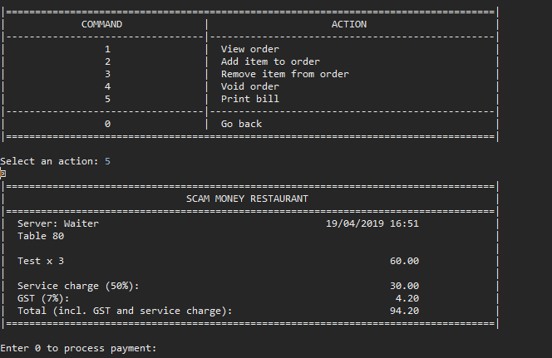

|  |  |  |  |  |  |  |  |  |  |  |
| --- | --- | --- | --- | --- | --- | --- | --- | --- | --- | --- |
| **Test Case ID** | | 08-06 | **Test Case Description** | | Exit | | | | | |
|  |  |  |  |  |  |  |  |  |  |  |
|  |  |  |  |  |  |  |  |  |  |  |
| **Date Tested** | | 12-Apr-2019 | | **Test Case (Pass/Fail/Not Executed)** | | Pass | |
|  |  |  |  |  |  |  |  |  |  |  |
| **S #** | **Prerequisites:** | | |  |
| 1 | 08 | | |  |
| 2 |  | | |  |
| 3 |  | | |  |
| 4 |  | | |  |
|  |  |  |  |  |  |  |  |  |  |  |
| **Test Scenario** |  | | | | | |  |  |  |  |
|  |  |  |  |  |  |  |  |  |  |  |
| **Step #** | **Step Details** | | **Expected Results** | | **Actual Results** | | | **Pass / Fail / Not executed / Suspended** | | |
|
| 1 | Input ‘0’ | | Return to main menu | | As expected | | | Pass | | |
|  |  | |  | |  | | |  | | |
|  |  | |  | |  | | |  | | |
|  |  | |  | |  | | |  | | |
|  |  | |  | |  | | |  | | |
|  |  | |  | |  | | |  | | |

|  |  |  |  |  |  |  |  |  |  |  |
| --- | --- | --- | --- | --- | --- | --- | --- | --- | --- | --- |
| **Test Case ID** | | 08-6 | **Test Case Description** | | Invalid | | | | | |
|  |  |  |  |  |  |  |  |  |  |  |
|  |  |  |  |  |  |  |  |  |  |  |
| **Date Tested** | | 12-Apr-2019 | | **Test Case (Pass/Fail/Not Executed)** | | Pass | |
|  |  |  |  |  |  |  |  |  |  |  |
| **S #** | **Prerequisites:** | | |  |
| 1 | 08 | | |  |
| 2 |  | | |  |
| 3 |  | | |  |
| 4 |  | | |  |
|  |  |  |  |  |  |  |  |  |  |  |
| **Test Scenario** |  | | | | | |  |  |  |  |
|  |  |  |  |  |  |  |  |  |  |  |
| **Step #** | **Step Details** | | **Expected Results** | | **Actual Results** | | | **Pass / Fail / Not executed / Suspended** | | |
|
| 1 | Input unexpected value | | Error message | | As expected | | | Pass | | |
|  |  | |  | |  | | |  | | |
|  |  | |  | |  | | |  | | |
|  |  | |  | |  | | |  | | |
|  |  | |  | |  | | |  | | |
|  |  | |  | |  | | |  | | |

|  |  |  |  |  |  |  |  |  |  |  |
| --- | --- | --- | --- | --- | --- | --- | --- | --- | --- | --- |
| **Test Case ID** | | 09 | **Test Case Description** | | View all reservations | | | | | |
|  |  |  |  |  |  |  |  |  |  |  |
|  |  |  |  |  |  |  |  |  |  |  |
| **Date Tested** | | 12-Apr-2019 | | **Test Case (Pass/Fail/Not Executed)** | |  | |
|  |  |  |  |  |  |  |  |  |  |  |
| **S #** | **Prerequisites:** | | |  |
| 1 | 00-1 | | |  |
| 2 | At least 1 reservation | | |  |
| 3 |  | | |  |
| 4 |  | | |  |
|  |  |  |  |  |  |  |  |  |  |  |
| **Test Scenario** |  | | | | | |  |  |  |  |
|  |  |  |  |  |  |  |  |  |  |  |
| **Step #** | **Step Details** | | **Expected Results** | | **Actual Results** | | | **Pass / Fail / Not executed / Suspended** | | |
|
| 1 | Input ‘9’ | | All reservations shown | | As expected | | | Pass | | |
|  |  | |  | |  | | |  | | |
|  |  | |  | |  | | |  | | |
|  |  | |  | |  | | |  | | |
|  |  | |  | |  | | |  | | |
|  |  | |  | |  | | |  | | |

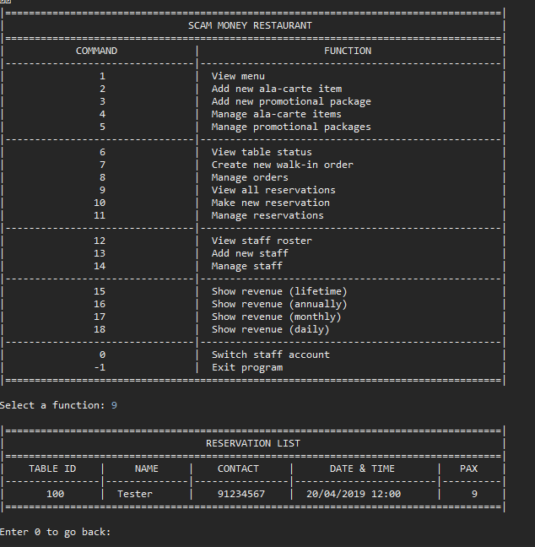

|  |  |  |  |  |  |  |  |  |  |  |
| --- | --- | --- | --- | --- | --- | --- | --- | --- | --- | --- |
| **Test Case ID** | | 09-1 | **Test Case Description** | | Exit | | | | | |
|  |  |  |  |  |  |  |  |  |  |  |
|  |  |  |  |  |  |  |  |  |  |  |
| **Date Tested** | | 12-Apr-2019 | | **Test Case (Pass/Fail/Not Executed)** | | Pass | |
|  |  |  |  |  |  |  |  |  |  |  |
| **S #** | **Prerequisites:** | | |  |
| 1 | 09 | | |  |
| 2 |  | | |  |
| 3 |  | | |  |
| 4 |  | | |  |
|  |  |  |  |  |  |  |  |  |  |  |
| **Test Scenario** |  | | | | | |  |  |  |  |
|  |  |  |  |  |  |  |  |  |  |  |
| **Step #** | **Step Details** | | **Expected Results** | | **Actual Results** | | | **Pass / Fail / Not executed / Suspended** | | |
|
| 1 | Input ‘0’ | | Return to main menu | | As expected | | | Pass | | |
|  |  | |  | |  | | |  | | |
|  |  | |  | |  | | |  | | |
|  |  | |  | |  | | |  | | |
|  |  | |  | |  | | |  | | |
|  |  | |  | |  | | |  | | |

|  |  |  |  |  |  |  |  |  |  |  |
| --- | --- | --- | --- | --- | --- | --- | --- | --- | --- | --- |
| **Test Case ID** | | 09-2 | **Test Case Description** | | Invalid | | | | | |
|  |  |  |  |  |  |  |  |  |  |  |
|  |  |  |  |  |  |  |  |  |  |  |
| **Date Tested** | | 12-Apr-2019 | | **Test Case (Pass/Fail/Not Executed)** | | Pass | |
|  |  |  |  |  |  |  |  |  |  |  |
| **S #** | **Prerequisites:** | | |  |
| 1 | 09 | | |  |
| 2 |  | | |  |
| 3 |  | | |  |
| 4 |  | | |  |
|  |  |  |  |  |  |  |  |  |  |  |
| **Test Scenario** |  | | | | | |  |  |  |  |
|  |  |  |  |  |  |  |  |  |  |  |
| **Step #** | **Step Details** | | **Expected Results** | | **Actual Results** | | | **Pass / Fail / Not executed / Suspended** | | |
|
| 1 | Input unexpected value | | Error message | | As expected | | | Pass | | |
|  |  | |  | |  | | |  | | |
|  |  | |  | |  | | |  | | |
|  |  | |  | |  | | |  | | |
|  |  | |  | |  | | |  | | |
|  |  | |  | |  | | |  | | |

|  |  |  |  |  |  |  |  |  |  |  |
| --- | --- | --- | --- | --- | --- | --- | --- | --- | --- | --- |
| **Test Case ID** | | 10 | **Test Case Description** | | Make new reservations | | | | | |
|  |  |  |  |  |  |  |  |  |  |  |
|  |  |  |  |  |  |  |  |  |  |  |
| **Date Tested** | | 12-Apr-2019 | | **Test Case (Pass/Fail/Not Executed)** | | Pass | |
|  |  |  |  |  |  |  |  |  |  |  |
| **S #** | **Prerequisites:** | | |  |
| 1 | 00-1 | | |  |
| 2 |  | | |  |
| 3 |  | | |  |
| 4 |  | | |  |
|  |  |  |  |  |  |  |  |  |  |  |
| **Test Scenario** |  | | | | | |  |  |  |  |
|  |  |  |  |  |  |  |  |  |  |  |
| **Step #** | **Step Details** | | **Expected Results** | | **Actual Results** | | | **Pass / Fail / Not executed / Suspended** | | |
|
| 1 | Input ‘10’ | | Prompt to enter Date | | As expected | | | Pass | | |
|  |  | |  | |  | | |  | | |
|  |  | |  | |  | | |  | | |
|  |  | |  | |  | | |  | | |
|  |  | |  | |  | | |  | | |
|  |  | |  | |  | | |  | | |

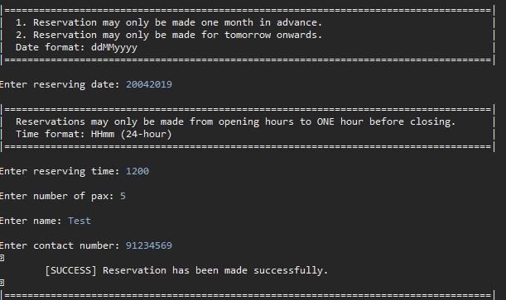

|  |  |  |  |  |  |  |  |  |  |  |
| --- | --- | --- | --- | --- | --- | --- | --- | --- | --- | --- |
| **Test Case ID** | | 10-1 | **Test Case Description** | | Date | | | | | |
|  |  |  |  |  |  |  |  |  |  |  |
|  |  |  |  |  |  |  |  |  |  |  |
| **Date Tested** | | 12-Apr-2019 | | **Test Case (Pass/Fail/Not Executed)** | | Pass | |
|  |  |  |  |  |  |  |  |  |  |  |
| **S #** | **Prerequisites:** | | |  |
| 1 | 10 | | |  |
| 2 |  | | |  |
| 3 |  | | |  |
| 4 |  | | |  |
|  |  |  |  |  |  |  |  |  |  |  |
| **Test Scenario** |  | | | | | |  |  |  |  |
|  |  |  |  |  |  |  |  |  |  |  |
| **Step #** | **Step Details** | | **Expected Results** | | **Actual Results** | | | **Pass / Fail / Not executed / Suspended** | | |
|
| 1 | Input ‘15042019’ | | Prompt to enter time | | As expected | | | Pass | | |
|  |  | |  | |  | | |  | | |
|  |  | |  | |  | | |  | | |
|  |  | |  | |  | | |  | | |
|  |  | |  | |  | | |  | | |
|  |  | |  | |  | | |  | | |

|  |  |  |  |  |  |  |  |  |  |  |
| --- | --- | --- | --- | --- | --- | --- | --- | --- | --- | --- |
| **Test Case ID** | | 10-1-1 | **Test Case Description** | | Invalid Date | | | | | |
|  |  |  |  |  |  |  |  |  |  |  |
|  |  |  |  |  |  |  |  |  |  |  |
| **Date Tested** | | 12-Apr-2019 | | **Test Case (Pass/Fail/Not Executed)** | | Pass | |
|  |  |  |  |  |  |  |  |  |  |  |
| **S #** | **Prerequisites:** | | |  |
| 1 | 10 | | |  |
| 2 |  | | |  |
| 3 |  | | |  |
| 4 |  | | |  |
|  |  |  |  |  |  |  |  |  |  |  |
| **Test Scenario** |  | | | | | |  |  |  |  |
|  |  |  |  |  |  |  |  |  |  |  |
| **Step #** | **Step Details** | | **Expected Results** | | **Actual Results** | | | **Pass / Fail / Not executed / Suspended** | | |
|
| 1 | Input ‘13032019’ | | Error message | | As expected | | | Pass | | |
|  |  | |  | |  | | |  | | |
|  |  | |  | |  | | |  | | |
|  |  | |  | |  | | |  | | |
|  |  | |  | |  | | |  | | |
|  |  | |  | |  | | |  | | |

|  |  |  |  |  |  |  |  |  |  |  |
| --- | --- | --- | --- | --- | --- | --- | --- | --- | --- | --- |
| **Test Case ID** | | 10-1-2 | **Test Case Description** | | Invalid format | | | | | |
|  |  |  |  |  |  |  |  |  |  |  |
|  |  |  |  |  |  |  |  |  |  |  |
| **Date Tested** | | 12-Apr-2019 | | **Test Case (Pass/Fail/Not Executed)** | | Pass | |
|  |  |  |  |  |  |  |  |  |  |  |
| **S #** | **Prerequisites:** | | |  |
| 1 | 10 | | |  |
| 2 |  | | |  |
| 3 |  | | |  |
| 4 |  | | |  |
|  |  |  |  |  |  |  |  |  |  |  |
| **Test Scenario** |  | | | | | |  |  |  |  |
|  |  |  |  |  |  |  |  |  |  |  |
| **Step #** | **Step Details** | | **Expected Results** | | **Actual Results** | | | **Pass / Fail / Not executed / Suspended** | | |
|
| 1 | Input ‘20190415’ | | Error message | | As expected | | | Pass | | |
|  |  | |  | |  | | |  | | |
|  |  | |  | |  | | |  | | |
|  |  | |  | |  | | |  | | |
|  |  | |  | |  | | |  | | |
|  |  | |  | |  | | |  | | |

|  |  |  |  |  |  |  |  |  |  |  |
| --- | --- | --- | --- | --- | --- | --- | --- | --- | --- | --- |
| **Test Case ID** | | 10-2 | **Test Case Description** | | Time | | | | | |
|  |  |  |  |  |  |  |  |  |  |  |
|  |  |  |  |  |  |  |  |  |  |  |
| **Date Tested** | | 12-Apr-2019 | | **Test Case (Pass/Fail/Not Executed)** | | Pass | |
|  |  |  |  |  |  |  |  |  |  |  |
| **S #** | **Prerequisites:** | | |  |
| 1 | 10-1 | | |  |
| 2 |  | | |  |
| 3 |  | | |  |
| 4 |  | | |  |
|  |  |  |  |  |  |  |  |  |  |  |
| **Test Scenario** |  | | | | | |  |  |  |  |
|  |  |  |  |  |  |  |  |  |  |  |
| **Step #** | **Step Details** | | **Expected Results** | | **Actual Results** | | | **Pass / Fail / Not executed / Suspended** | | |
|
| 1 | Input ‘1200’ | | Prompt to enter pax | | As expected | | | Pass | | |
|  |  | |  | |  | | |  | | |
|  |  | |  | |  | | |  | | |
|  |  | |  | |  | | |  | | |
|  |  | |  | |  | | |  | | |
|  |  | |  | |  | | |  | | |

|  |  |  |  |  |  |  |  |  |  |  |
| --- | --- | --- | --- | --- | --- | --- | --- | --- | --- | --- |
| **Test Case ID** | | 10-2-1 | **Test Case Description** | | Invalid time | | | | | |
|  |  |  |  |  |  |  |  |  |  |  |
|  |  |  |  |  |  |  |  |  |  |  |
| **Date Tested** | | 12-Apr-2019 | | **Test Case (Pass/Fail/Not Executed)** | | Pass | |
|  |  |  |  |  |  |  |  |  |  |  |
| **S #** | **Prerequisites:** | | |  |
| 1 | 10-1 | | |  |
| 2 |  | | |  |
| 3 |  | | |  |
| 4 |  | | |  |
|  |  |  |  |  |  |  |  |  |  |  |
| **Test Scenario** |  | | | | | |  |  |  |  |
|  |  |  |  |  |  |  |  |  |  |  |
| **Step #** | **Step Details** | | **Expected Results** | | **Actual Results** | | | **Pass / Fail / Not executed / Suspended** | | |
|
| 1 | Input ‘2359’ | | Error message | | As expected | | | Pass | | |
|  |  | |  | |  | | |  | | |
|  |  | |  | |  | | |  | | |
|  |  | |  | |  | | |  | | |
|  |  | |  | |  | | |  | | |
|  |  | |  | |  | | |  | | |

|  |  |  |  |  |  |  |  |  |  |  |
| --- | --- | --- | --- | --- | --- | --- | --- | --- | --- | --- |
| **Test Case ID** | | 10-2-2 | **Test Case Description** | | Invalid format | | | | | |
|  |  |  |  |  |  |  |  |  |  |  |
|  |  |  |  |  |  |  |  |  |  |  |
| **Date Tested** | | 12-Apr-2019 | | **Test Case (Pass/Fail/Not Executed)** | | Pass | |
|  |  |  |  |  |  |  |  |  |  |  |
| **S #** | **Prerequisites:** | | |  |
| 1 | 10-1 | | |  |
| 2 |  | | |  |
| 3 |  | | |  |
| 4 |  | | |  |
|  |  |  |  |  |  |  |  |  |  |  |
| **Test Scenario** |  | | | | | |  |  |  |  |
|  |  |  |  |  |  |  |  |  |  |  |
| **Step #** | **Step Details** | | **Expected Results** | | **Actual Results** | | | **Pass / Fail / Not executed / Suspended** | | |
|
| 1 | Input ‘Test’ | | Error message | | As expected | | | Pass | | |
|  |  | |  | |  | | |  | | |
|  |  | |  | |  | | |  | | |
|  |  | |  | |  | | |  | | |
|  |  | |  | |  | | |  | | |
|  |  | |  | |  | | |  | | |

|  |  |  |  |  |  |  |  |  |  |  |
| --- | --- | --- | --- | --- | --- | --- | --- | --- | --- | --- |
| **Test Case ID** | | 10-3 | **Test Case Description** | | Pax | | | | | |
|  |  |  |  |  |  |  |  |  |  |  |
|  |  |  |  |  |  |  |  |  |  |  |
| **Date Tested** | | 12-Apr-2019 | | **Test Case (Pass/Fail/Not Executed)** | |  | |
|  |  |  |  |  |  |  |  |  |  |  |
| **S #** | **Prerequisites:** | | |  |
| 1 | 10-2 | | |  |
| 2 |  | | |  |
| 3 |  | | |  |
| 4 |  | | |  |
|  |  |  |  |  |  |  |  |  |  |  |
| **Test Scenario** |  | | | | | |  |  |  |  |
|  |  |  |  |  |  |  |  |  |  |  |
| **Step #** | **Step Details** | | **Expected Results** | | **Actual Results** | | | **Pass / Fail / Not executed / Suspended** | | |
|
| 1 | Input ‘8’ | | Prompt to enter name | | As expected | | | Pass | | |
|  |  | |  | |  | | |  | | |
|  |  | |  | |  | | |  | | |
|  |  | |  | |  | | |  | | |
|  |  | |  | |  | | |  | | |
|  |  | |  | |  | | |  | | |

|  |  |  |  |  |  |  |  |  |  |  |
| --- | --- | --- | --- | --- | --- | --- | --- | --- | --- | --- |
| **Test Case ID** | | 10-3-1 | **Test Case Description** | | Full reservation | | | | | |
|  |  |  |  |  |  |  |  |  |  |  |
|  |  |  |  |  |  |  |  |  |  |  |
| **Date Tested** | | 12-Apr-2019 | | **Test Case (Pass/Fail/Not Executed)** | | Pass | |
|  |  |  |  |  |  |  |  |  |  |  |
| **S #** | **Prerequisites:** | | |  |
| 1 | 10-2 | | |  |
| 2 | No tables left for reservation | | |  |
| 3 |  | | |  |
| 4 |  | | |  |
|  |  |  |  |  |  |  |  |  |  |  |
| **Test Scenario** |  | | | | | |  |  |  |  |
|  |  |  |  |  |  |  |  |  |  |  |
| **Step #** | **Step Details** | | **Expected Results** | | **Actual Results** | | | **Pass / Fail / Not executed / Suspended** | | |
|
| 1 | Input ‘8’ | | Return to main menu | | As expected | | | Pass | | |
|  |  | |  | |  | | |  | | |
|  |  | |  | |  | | |  | | |
|  |  | |  | |  | | |  | | |
|  |  | |  | |  | | |  | | |
|  |  | |  | |  | | |  | | |

|  |  |  |  |  |  |  |  |  |  |  |
| --- | --- | --- | --- | --- | --- | --- | --- | --- | --- | --- |
| **Test Case ID** | | 10-3-2 | **Test Case Description** | | Invalid | | | | | |
|  |  |  |  |  |  |  |  |  |  |  |
|  |  |  |  |  |  |  |  |  |  |  |
| **Date Tested** | | 12-Apr-2019 | | **Test Case (Pass/Fail/Not Executed)** | | Pass | |
|  |  |  |  |  |  |  |  |  |  |  |
| **S #** | **Prerequisites:** | | |  |
| 1 | 10-2 | | |  |
| 2 |  | | |  |
| 3 |  | | |  |
| 4 |  | | |  |
|  |  |  |  |  |  |  |  |  |  |  |
| **Test Scenario** |  | | | | | |  |  |  |  |
|  |  |  |  |  |  |  |  |  |  |  |
| **Step #** | **Step Details** | | **Expected Results** | | **Actual Results** | | | **Pass / Fail / Not executed / Suspended** | | |
|
| 1 | Input ‘Test’ | | Error message | | As expected | | | Pass | | |
|  |  | |  | |  | | |  | | |
|  |  | |  | |  | | |  | | |
|  |  | |  | |  | | |  | | |
|  |  | |  | |  | | |  | | |
|  |  | |  | |  | | |  | | |

|  |  |  |  |  |  |  |  |  |  |  |
| --- | --- | --- | --- | --- | --- | --- | --- | --- | --- | --- |
| **Test Case ID** | | 10-4 | **Test Case Description** | | Nam | | | | | |
|  |  |  |  |  |  |  |  |  |  |  |
|  |  |  |  |  |  |  |  |  |  |  |
| **Date Tested** | | 12-Apr-2019 | | **Test Case (Pass/Fail/Not Executed)** | | Pass | |
|  |  |  |  |  |  |  |  |  |  |  |
| **S #** | **Prerequisites:** | | |  |
| 1 | 10-3 | | |  |
| 2 |  | | |  |
| 3 |  | | |  |
| 4 |  | | |  |
|  |  |  |  |  |  |  |  |  |  |  |
| **Test Scenario** |  | | | | | |  |  |  |  |
|  |  |  |  |  |  |  |  |  |  |  |
| **Step #** | **Step Details** | | **Expected Results** | | **Actual Results** | | | **Pass / Fail / Not executed / Suspended** | | |
|
| 1 | Input ‘Test’ | | Prompt to enter contact | | As expected | | | Pass | | |
|  |  | |  | |  | | |  | | |
|  |  | |  | |  | | |  | | |
|  |  | |  | |  | | |  | | |
|  |  | |  | |  | | |  | | |
|  |  | |  | |  | | |  | | |

|  |  |  |  |  |  |  |  |  |  |  |
| --- | --- | --- | --- | --- | --- | --- | --- | --- | --- | --- |
| **Test Case ID** | | 10-5 | **Test Case Description** | | Contact number | | | | | |
|  |  |  |  |  |  |  |  |  |  |  |
|  |  |  |  |  |  |  |  |  |  |  |
| **Date Tested** | | 12-Apr-2019 | | **Test Case (Pass/Fail/Not Executed)** | | Pass | |
|  |  |  |  |  |  |  |  |  |  |  |
| **S #** | **Prerequisites:** | | |  |
| 1 | 10-4 | | |  |
| 2 |  | | |  |
| 3 |  | | |  |
| 4 |  | | |  |
|  |  |  |  |  |  |  |  |  |  |  |
| **Test Scenario** |  | | | | | |  |  |  |  |
|  |  |  |  |  |  |  |  |  |  |  |
| **Step #** | **Step Details** | | **Expected Results** | | **Actual Results** | | | **Pass / Fail / Not executed / Suspended** | | |
|
| 1 | Input ‘91234567’ | | Return to main menu | | As expected | | | Pass | | |
|  |  | |  | |  | | |  | | |
|  |  | |  | |  | | |  | | |
|  |  | |  | |  | | |  | | |
|  |  | |  | |  | | |  | | |
|  |  | |  | |  | | |  | | |

|  |  |  |  |  |  |  |  |  |  |  |
| --- | --- | --- | --- | --- | --- | --- | --- | --- | --- | --- |
| **Test Case ID** | | 10-5-1 | **Test Case Description** | | Invalid Number | | | | | |
|  |  |  |  |  |  |  |  |  |  |  |
|  |  |  |  |  |  |  |  |  |  |  |
| **Date Tested** | | 12-Apr-2019 | | **Test Case (Pass/Fail/Not Executed)** | | Pass | |
|  |  |  |  |  |  |  |  |  |  |  |
| **S #** | **Prerequisites:** | | |  |
| 1 | 10-4 | | |  |
| 2 |  | | |  |
| 3 |  | | |  |
| 4 |  | | |  |
|  |  |  |  |  |  |  |  |  |  |  |
| **Test Scenario** |  | | | | | |  |  |  |  |
|  |  |  |  |  |  |  |  |  |  |  |
| **Step #** | **Step Details** | | **Expected Results** | | **Actual Results** | | | **Pass / Fail / Not executed / Suspended** | | |
|
| 1 | Input ‘9123456’ | | Error message | | As expected | | | Pass | | |
|  |  | |  | |  | | |  | | |
|  |  | |  | |  | | |  | | |
|  |  | |  | |  | | |  | | |
|  |  | |  | |  | | |  | | |
|  |  | |  | |  | | |  | | |

|  |  |  |  |  |  |  |  |  |  |  |
| --- | --- | --- | --- | --- | --- | --- | --- | --- | --- | --- |
| **Test Case ID** | | 10-5-2 | **Test Case Description** | | Invalid | | | | | |
|  |  |  |  |  |  |  |  |  |  |  |
|  |  |  |  |  |  |  |  |  |  |  |
| **Date Tested** | | 12-Apr-2019 | | **Test Case (Pass/Fail/Not Executed)** | | Pass | |
|  |  |  |  |  |  |  |  |  |  |  |
| **S #** | **Prerequisites:** | | |  |
| 1 | 10-4 | | |  |
| 2 |  | | |  |
| 3 |  | | |  |
| 4 |  | | |  |
|  |  |  |  |  |  |  |  |  |  |  |
| **Test Scenario** |  | | | | | |  |  |  |  |
|  |  |  |  |  |  |  |  |  |  |  |
| **Step #** | **Step Details** | | **Expected Results** | | **Actual Results** | | | **Pass / Fail / Not executed / Suspended** | | |
|
| 1 | Input ‘Test’ | | Error message | | As expected | | | Pass | | |
|  |  | |  | |  | | |  | | |
|  |  | |  | |  | | |  | | |
|  |  | |  | |  | | |  | | |
|  |  | |  | |  | | |  | | |
|  |  | |  | |  | | |  | | |

|  |  |  |  |  |  |  |  |  |  |  |
| --- | --- | --- | --- | --- | --- | --- | --- | --- | --- | --- |
| **Test Case ID** | | 10-6 | **Test Case Description** | | Reservation timeout | | | | | |
|  |  |  |  |  |  |  |  |  |  |  |
|  |  |  |  |  |  |  |  |  |  |  |
| **Date Tested** | | 12-Apr-2019 | | **Test Case (Pass/Fail/Not Executed)** | | Pass | |
|  |  |  |  |  |  |  |  |  |  |  |
| **S #** | **Prerequisites:** | | |  |
| 1 | Reservation timing out within 5 minutes | | |  |
| 2 |  | | |  |
| 3 |  | | |  |
| 4 |  | | |  |
|  |  |  |  |  |  |  |  |  |  |  |
| **Test Scenario** |  | | | | | |  |  |  |  |
|  |  |  |  |  |  |  |  |  |  |  |
| **Step #** | **Step Details** | | **Expected Results** | | **Actual Results** | | | **Pass / Fail / Not executed / Suspended** | | |
|
| 1 | Input ‘9’ | | Reservation shown | | As expected | | | Pass | | |
| 2 | Wait till timeout and input ‘9’ | | Reservation removed | | As expected | | | Pass | | |
|  |  | |  | |  | | |  | | |
|  |  | |  | |  | | |  | | |
|  |  | |  | |  | | |  | | |
|  |  | |  | |  | | |  | | |

|  |  |  |  |  |  |  |  |  |  |  |
| --- | --- | --- | --- | --- | --- | --- | --- | --- | --- | --- |
| **Test Case ID** | | 11 | **Test Case Description** | | Manage Reservation | | | | | |
|  |  |  |  |  |  |  |  |  |  |  |
|  |  |  |  |  |  |  |  |  |  |  |
| **Date Tested** | | 12-Apr-2019 | | **Test Case (Pass/Fail/Not Executed)** | | Pass | |
|  |  |  |  |  |  |  |  |  |  |  |
| **S #** | **Prerequisites:** | | |  |
| 1 | 00-1 | | |  |
| 2 | At least 1 reservation | | |  |
| 3 |  | | |  |
| 4 |  | | |  |
|  |  |  |  |  |  |  |  |  |  |  |
| **Test Scenario** |  | | | | | |  |  |  |  |
|  |  |  |  |  |  |  |  |  |  |  |
| **Step #** | **Step Details** | | **Expected Results** | | **Actual Results** | | | **Pass / Fail / Not executed / Suspended** | | |
|
| 1 | Input ‘11’ | | Prompt enter reservation contact | | As expected | | | Pass | | |
| 2 | Input ‘91234567’ | | Prompt to choose reservation | | As expected | | | Pass | | |
| 3 | Input ‘1’ | | Prompt to choose manage option | | As expected | | | Pass | | |
|  |  | |  | |  | | |  | | |
|  |  | |  | |  | | |  | | |
|  |  | |  | |  | | |  | | |

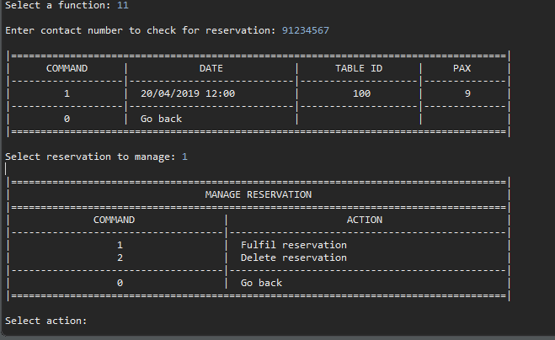

|  |  |  |  |  |  |  |  |  |  |  |
| --- | --- | --- | --- | --- | --- | --- | --- | --- | --- | --- |
| **Test Case ID** | | 11-1 | **Test Case Description** | | Fulfill | | | | | |
|  |  |  |  |  |  |  |  |  |  |  |
|  |  |  |  |  |  |  |  |  |  |  |
| **Date Tested** | | 12-Apr-2019 | | **Test Case (Pass/Fail/Not Executed)** | | Pass | |
|  |  |  |  |  |  |  |  |  |  |  |
| **S #** | **Prerequisites:** | | |  |
| 1 | 11 | | |  |
| 2 |  | | |  |
| 3 |  | | |  |
| 4 |  | | |  |
|  |  |  |  |  |  |  |  |  |  |  |
| **Test Scenario** |  | | | | | |  |  |  |  |
|  |  |  |  |  |  |  |  |  |  |  |
| **Step #** | **Step Details** | | **Expected Results** | | **Actual Results** | | | **Pass / Fail / Not executed / Suspended** | | |
|
| 1 | Input ‘1’ | | Return to main menu | | As expected | | | Pass | | |
| 2 | Input ‘6’ | | Table is now occupied | | As expected | | | Pass | | |
| 3 | Return to main menu and input ‘11’ | | Reservation is removed | | As expected | | | Pass | | |
|  |  | |  | |  | | |  | | |
|  |  | |  | |  | | |  | | |
|  |  | |  | |  | | |  | | |

|  |  |  |  |  |  |  |  |  |  |  |
| --- | --- | --- | --- | --- | --- | --- | --- | --- | --- | --- |
| **Test Case ID** | | 11-2 | **Test Case Description** | | Delete | | | | | |
|  |  |  |  |  |  |  |  |  |  |  |
|  |  |  |  |  |  |  |  |  |  |  |
| **Date Tested** | | 12-Apr-2019 | | **Test Case (Pass/Fail/Not Executed)** | | Pass | |
|  |  |  |  |  |  |  |  |  |  |  |
| **S #** | **Prerequisites:** | | |  |
| 1 | 11 | | |  |
| 2 |  | | |  |
| 3 |  | | |  |
| 4 |  | | |  |
|  |  |  |  |  |  |  |  |  |  |  |
| **Test Scenario** |  | | | | | |  |  |  |  |
|  |  |  |  |  |  |  |  |  |  |  |
| **Step #** | **Step Details** | | **Expected Results** | | **Actual Results** | | | **Pass / Fail / Not executed / Suspended** | | |
|
| 1 | Input ‘2’ | | Return to main menu | | As expected | | | Pass | | |
| 2 | Input ‘11’ | | Reservation is removed | | As expected | | | Pass | | |
|  |  | |  | |  | | |  | | |
|  |  | |  | |  | | |  | | |
|  |  | |  | |  | | |  | | |
|  |  | |  | |  | | |  | | |

|  |  |  |  |  |  |  |  |  |  |  |
| --- | --- | --- | --- | --- | --- | --- | --- | --- | --- | --- |
| **Test Case ID** | | 11-3 | **Test Case Description** | | Invalid number | | | | | |
|  |  |  |  |  |  |  |  |  |  |  |
|  |  |  |  |  |  |  |  |  |  |  |
| **Date Tested** | | 12-Apr-2019 | | **Test Case (Pass/Fail/Not Executed)** | |  | |
|  |  |  |  |  |  |  |  |  |  |  |
| **S #** | **Prerequisites:** | | |  |
| 1 | 11 | | |  |
| 2 |  | | |  |
| 3 |  | | |  |
| 4 |  | | |  |
|  |  |  |  |  |  |  |  |  |  |  |
| **Test Scenario** |  | | | | | |  |  |  |  |
|  |  |  |  |  |  |  |  |  |  |  |
| **Step #** | **Step Details** | | **Expected Results** | | **Actual Results** | | | **Pass / Fail / Not executed / Suspended** | | |
|
| 1 | Input ‘97654321’ | | Return to main menu | | As expected | | | Pass | | |
|  |  | |  | |  | | |  | | |
|  |  | |  | |  | | |  | | |
|  |  | |  | |  | | |  | | |
|  |  | |  | |  | | |  | | |
|  |  | |  | |  | | |  | | |

|  |  |  |  |  |  |  |  |  |  |  |
| --- | --- | --- | --- | --- | --- | --- | --- | --- | --- | --- |
| **Test Case ID** | | 11-4 | **Test Case Description** | | Invalid | | | | | |
|  |  |  |  |  |  |  |  |  |  |  |
|  |  |  |  |  |  |  |  |  |  |  |
| **Date Tested** | | 12-Apr-2019 | | **Test Case (Pass/Fail/Not Executed)** | | Pass | |
|  |  |  |  |  |  |  |  |  |  |  |
| **S #** | **Prerequisites:** | | |  |
| 1 | 11 | | |  |
| 2 |  | | |  |
| 3 |  | | |  |
| 4 |  | | |  |
|  |  |  |  |  |  |  |  |  |  |  |
| **Test Scenario** |  | | | | | |  |  |  |  |
|  |  |  |  |  |  |  |  |  |  |  |
| **Step #** | **Step Details** | | **Expected Results** | | **Actual Results** | | | **Pass / Fail / Not executed / Suspended** | | |
|
| 1 | Input unexpected value | | Error message | | As expected | | | Pass | | |
|  |  | |  | |  | | |  | | |
|  |  | |  | |  | | |  | | |
|  |  | |  | |  | | |  | | |
|  |  | |  | |  | | |  | | |
|  |  | |  | |  | | |  | | |

|  |  |  |  |  |  |  |  |  |  |  |
| --- | --- | --- | --- | --- | --- | --- | --- | --- | --- | --- |
| **Test Case ID** | | 12 | **Test Case Description** | | View Staff Roster | | | | | |
|  |  |  |  |  |  |  |  |  |  |  |
|  |  |  |  |  |  |  |  |  |  |  |
| **Date Tested** | | 12-Apr-2019 | | **Test Case (Pass/Fail/Not Executed)** | | Pass | |
|  |  |  |  |  |  |  |  |  |  |  |
| **S #** | **Prerequisites:** | | |  |
| 1 | 00-1 | | |  |
| 2 |  | | |  |
| 3 |  | | |  |
| 4 |  | | |  |
|  |  |  |  |  |  |  |  |  |  |  |
| **Test Scenario** |  | | | | | |  |  |  |  |
|  |  |  |  |  |  |  |  |  |  |  |
| **Step #** | **Step Details** | | **Expected Results** | | **Actual Results** | | | **Pass / Fail / Not executed / Suspended** | | |
|
| 1 | Input ‘12’ | | Staff list shown | | As expected | | | Pass | | |
|  |  | |  | |  | | |  | | |
|  |  | |  | |  | | |  | | |
|  |  | |  | |  | | |  | | |
|  |  | |  | |  | | |  | | |
|  |  | |  | |  | | |  | | |

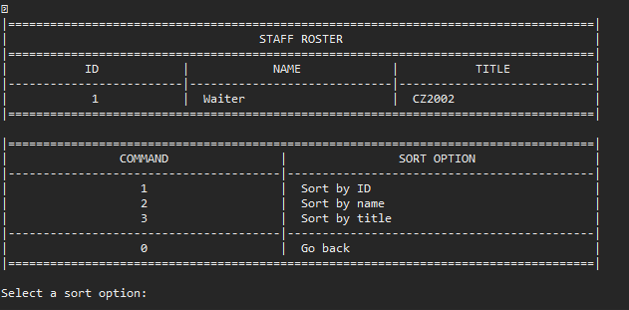

|  |  |  |  |  |  |  |  |  |  |  |
| --- | --- | --- | --- | --- | --- | --- | --- | --- | --- | --- |
| **Test Case ID** | | 12-1 | **Test Case Description** | | Sort by ID | | | | | |
|  |  |  |  |  |  |  |  |  |  |  |
|  |  |  |  |  |  |  |  |  |  |  |
| **Date Tested** | | 12-Apr-2019 | | **Test Case (Pass/Fail/Not Executed)** | |  | |
|  |  |  |  |  |  |  |  |  |  |  |
| **S #** | **Prerequisites:** | | |  |
| 1 | 12 | | |  |
| 2 |  | | |  |
| 3 |  | | |  |
| 4 |  | | |  |
|  |  |  |  |  |  |  |  |  |  |  |
| **Test Scenario** |  | | | | | |  |  |  |  |
|  |  |  |  |  |  |  |  |  |  |  |
| **Step #** | **Step Details** | | **Expected Results** | | **Actual Results** | | | **Pass / Fail / Not executed / Suspended** | | |
|
| 1 | Input ‘1’ | | Sorted by ID | | As expected | | | Pass | | |
|  |  | |  | |  | | |  | | |
|  |  | |  | |  | | |  | | |
|  |  | |  | |  | | |  | | |
|  |  | |  | |  | | |  | | |
|  |  | |  | |  | | |  | | |

|  |  |  |  |  |  |  |  |  |  |  |
| --- | --- | --- | --- | --- | --- | --- | --- | --- | --- | --- |
| **Test Case ID** | | 12-2 | **Test Case Description** | | Sort by name | | | | | |
|  |  |  |  |  |  |  |  |  |  |  |
|  |  |  |  |  |  |  |  |  |  |  |
| **Date Tested** | | 12-Apr-2019 | | **Test Case (Pass/Fail/Not Executed)** | | Pass | |
|  |  |  |  |  |  |  |  |  |  |  |
| **S #** | **Prerequisites:** | | |  |
| 1 | 12 | | |  |
| 2 |  | | |  |
| 3 |  | | |  |
| 4 |  | | |  |
|  |  |  |  |  |  |  |  |  |  |  |
| **Test Scenario** |  | | | | | |  |  |  |  |
|  |  |  |  |  |  |  |  |  |  |  |
| **Step #** | **Step Details** | | **Expected Results** | | **Actual Results** | | | **Pass / Fail / Not executed / Suspended** | | |
|
| 1 | Input ‘2’ | | Sorted by Name | | As expected | | | Pass | | |
|  |  | |  | |  | | |  | | |
|  |  | |  | |  | | |  | | |
|  |  | |  | |  | | |  | | |
|  |  | |  | |  | | |  | | |
|  |  | |  | |  | | |  | | |

|  |  |  |  |  |  |  |  |  |  |  |
| --- | --- | --- | --- | --- | --- | --- | --- | --- | --- | --- |
| **Test Case ID** | | 12-3 | **Test Case Description** | | Sort by title | | | | | |
|  |  |  |  |  |  |  |  |  |  |  |
|  |  |  |  |  |  |  |  |  |  |  |
| **Date Tested** | | 12-Apr-2019 | | **Test Case (Pass/Fail/Not Executed)** | | Pass | |
|  |  |  |  |  |  |  |  |  |  |  |
| **S #** | **Prerequisites:** | | |  |
| 1 | 11 | | |  |
| 2 |  | | |  |
| 3 |  | | |  |
| 4 |  | | |  |
|  |  |  |  |  |  |  |  |  |  |  |
| **Test Scenario** |  | | | | | |  |  |  |  |
|  |  |  |  |  |  |  |  |  |  |  |
| **Step #** | **Step Details** | | **Expected Results** | | **Actual Results** | | | **Pass / Fail / Not executed / Suspended** | | |
|
| 1 | Input ‘3’ | | Sorted by title | | As expected | | | Pass | | |
|  |  | |  | |  | | |  | | |
|  |  | |  | |  | | |  | | |
|  |  | |  | |  | | |  | | |
|  |  | |  | |  | | |  | | |
|  |  | |  | |  | | |  | | |

|  |  |  |  |  |  |  |  |  |  |  |
| --- | --- | --- | --- | --- | --- | --- | --- | --- | --- | --- |
| **Test Case ID** | | 11-4 | **Test Case Description** | | Exit | | | | | |
|  |  |  |  |  |  |  |  |  |  |  |
|  |  |  |  |  |  |  |  |  |  |  |
| **Date Tested** | | 12-Apr-2019 | | **Test Case (Pass/Fail/Not Executed)** | | Pass | |
|  |  |  |  |  |  |  |  |  |  |  |
| **S #** | **Prerequisites:** | | |  |
| 1 | 11 | | |  |
| 2 |  | | |  |
| 3 |  | | |  |
| 4 |  | | |  |
|  |  |  |  |  |  |  |  |  |  |  |
| **Test Scenario** |  | | | | | |  |  |  |  |
|  |  |  |  |  |  |  |  |  |  |  |
| **Step #** | **Step Details** | | **Expected Results** | | **Actual Results** | | | **Pass / Fail / Not executed / Suspended** | | |
|
| 1 | Input ‘0’ | | Return to main menu | | As expected | | | Pass | | |
|  |  | |  | |  | | |  | | |
|  |  | |  | |  | | |  | | |
|  |  | |  | |  | | |  | | |
|  |  | |  | |  | | |  | | |
|  |  | |  | |  | | |  | | |

|  |  |  |  |  |  |  |  |  |  |  |
| --- | --- | --- | --- | --- | --- | --- | --- | --- | --- | --- |
| **Test Case ID** | | 11-5 | **Test Case Description** | | Invalid | | | | | |
|  |  |  |  |  |  |  |  |  |  |  |
|  |  |  |  |  |  |  |  |  |  |  |
| **Date Tested** | | 12-Apr-2019 | | **Test Case (Pass/Fail/Not Executed)** | | Pass | |
|  |  |  |  |  |  |  |  |  |  |  |
| **S #** | **Prerequisites:** | | |  |
| 1 | 11 | | |  |
| 2 |  | | |  |
| 3 |  | | |  |
| 4 |  | | |  |
|  |  |  |  |  |  |  |  |  |  |  |
| **Test Scenario** |  | | | | | |  |  |  |  |
|  |  |  |  |  |  |  |  |  |  |  |
| **Step #** | **Step Details** | | **Expected Results** | | **Actual Results** | | | **Pass / Fail / Not executed / Suspended** | | |
|
| 1 | Input unexpected value | | Error message | | As expected | | | Pass | | |
|  |  | |  | |  | | |  | | |
|  |  | |  | |  | | |  | | |
|  |  | |  | |  | | |  | | |
|  |  | |  | |  | | |  | | |
|  |  | |  | |  | | |  | | |

|  |  |  |  |  |  |  |  |  |  |  |  |
| --- | --- | --- | --- | --- | --- | --- | --- | --- | --- | --- | --- |
| **Test Case ID** | |  | 13 | **Test Case Description** | | Add new staff | | | | | |
|  |  |  |  |  |  |  |  |  |  |  |  |
|  |  |  |  |  |  |  |  |  |  |  |  |
| **Date Tested** | |  | 12-Apr-2019 | | **Test Case (Pass/Fail/Not Executed)** | |  | |
|  |  |  |  |  |  |  |  |  |  |  |  |
| **S #** |  | **Prerequisites:** | | |  |
| 1 |  | 00-1 | | |  |
| 2 |  |  | | |  |
| 3 |  |  | | |  |
| 4 |  |  | | |  |
|  |  |  |  |  |  |  |  |  |  |  |  |
| **Test Scenario** |  |  | | | | | |  |  |  |  |
|  |  |  |  |  |  |  |  |  |  |  |  |
| **Step #** |  | **Step Details** | | **Expected Results** | | **Actual Results** | | | **Pass / Fail / Not executed / Suspended** | | |
|  |
| 1 |  | Input ‘13’ | | Prompt to enter name | | As expected | | | Pass | | |
| 2 |  | Input ‘Test’ | | Prompt to enter title | | As expected | | | Pass | | |
| 3 |  | Input ‘TestTitle’ | | Return to main menu | | As expected | | | Pass | | |
| 4 |  | Input ‘12’ | | Staff has been added | | As expected | | | Pass | | |
|  |  |  | |  | |  | | |  | | |
|  |  |  | |  | |  | | |  | | |

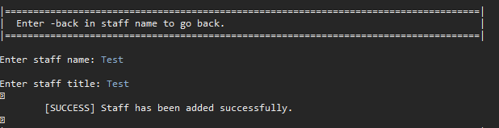

|  |  |  |  |  |  |  |  |  |  |  |
| --- | --- | --- | --- | --- | --- | --- | --- | --- | --- | --- |
| **Test Case ID** | | 14 | **Test Case Description** | | Manage Staff | | | | | |
|  |  |  |  |  |  |  |  |  |  |  |
|  |  |  |  |  |  |  |  |  |  |  |
| **Date Tested** | | 12-Apr-2019 | | **Test Case (Pass/Fail/Not Executed)** | |  | |
|  |  |  |  |  |  |  |  |  |  |  |
| **S #** | **Prerequisites:** | | |  |
| 1 | 00-1 | | |  |
| 2 |  | | |  |
| 3 |  | | |  |
| 4 |  | | |  |
|  |  |  |  |  |  |  |  |  |  |  |
| **Test Scenario** |  | | | | | |  |  |  |  |
|  |  |  |  |  |  |  |  |  |  |  |
| **Step #** | **Step Details** | | **Expected Results** | | **Actual Results** | | | **Pass / Fail / Not executed / Suspended** | | |
|
| 1 | Input ‘14’ | | Prompt to choose staff | | As expected | | | Pass | | |
| 2 | Input ‘1’ | | Prompt to choose management option | | As expected | | | Pass | | |
|  |  | |  | |  | | |  | | |
|  |  | |  | |  | | |  | | |
|  |  | |  | |  | | |  | | |
|  |  | |  | |  | | |  | | |

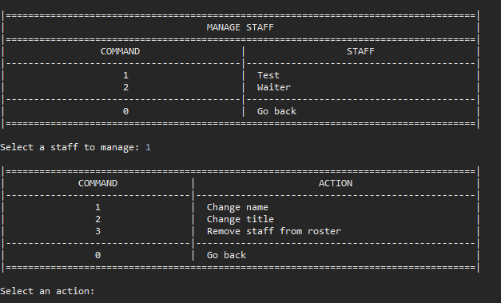

|  |  |  |  |  |  |  |  |  |  |  |
| --- | --- | --- | --- | --- | --- | --- | --- | --- | --- | --- |
| **Test Case ID** | | 14-1 | **Test Case Description** | | Change name | | | | | |
|  |  |  |  |  |  |  |  |  |  |  |
|  |  |  |  |  |  |  |  |  |  |  |
| **Date Tested** | | 12-Apr-2019 | | **Test Case (Pass/Fail/Not Executed)** | |  | |
|  |  |  |  |  |  |  |  |  |  |  |
| **S #** | **Prerequisites:** | | |  |
| 1 | 14 | | |  |
| 2 |  | | |  |
| 3 |  | | |  |
| 4 |  | | |  |
|  |  |  |  |  |  |  |  |  |  |  |
| **Test Scenario** |  | | | | | |  |  |  |  |
|  |  |  |  |  |  |  |  |  |  |  |
| **Step #** | **Step Details** | | **Expected Results** | | **Actual Results** | | | **Pass / Fail / Not executed / Suspended** | | |
|
| 1 | Input ‘1’ | | Prompt to enter new name | | As expected | | | Pass | | |
| 2 | Input ‘Test2’ | | Retun to main menu | | As expected | | | Pass | | |
| 3 | Input ‘12’ | | Staff name changed | | As expected | | | Pass | | |
|  |  | |  | |  | | |  | | |
|  |  | |  | |  | | |  | | |
|  |  | |  | |  | | |  | | |

|  |  |  |  |  |  |  |  |  |  |  |
| --- | --- | --- | --- | --- | --- | --- | --- | --- | --- | --- |
| **Test Case ID** | | 14-2 | **Test Case Description** | | Change title | | | | | |
|  |  |  |  |  |  |  |  |  |  |  |
|  |  |  |  |  |  |  |  |  |  |  |
| **Date Tested** | | 12-Apr-2019 | | **Test Case (Pass/Fail/Not Executed)** | |  | |
|  |  |  |  |  |  |  |  |  |  |  |
| **S #** | **Prerequisites:** | | |  |
| 1 | 14 | | |  |
| 2 |  | | |  |
| 3 |  | | |  |
| 4 |  | | |  |
|  |  |  |  |  |  |  |  |  |  |  |
| **Test Scenario** |  | | | | | |  |  |  |  |
|  |  |  |  |  |  |  |  |  |  |  |
| **Step #** | **Step Details** | | **Expected Results** | | **Actual Results** | | | **Pass / Fail / Not executed / Suspended** | | |
|
| 1 | Input ‘1’ | | Prompt to enter new title | | As expected | | | Pass | | |
| 2 | Input ‘Test2’ | | Retun to main menu | | As expected | | | Pass | | |
| 3 | Input ‘12’ | | Staff title changed | | As expected | | | Pass | | |
|  |  | |  | |  | | |  | | |
|  |  | |  | |  | | |  | | |
|  |  | |  | |  | | |  | | |

|  |  |  |  |  |  |  |  |  |  |  |
| --- | --- | --- | --- | --- | --- | --- | --- | --- | --- | --- |
| **Test Case ID** | | 14-3 | **Test Case Description** | | Remove | | | | | |
|  |  |  |  |  |  |  |  |  |  |  |
|  |  |  |  |  |  |  |  |  |  |  |
| **Date Tested** | | 12-Apr-2019 | | **Test Case (Pass/Fail/Not Executed)** | |  | |
|  |  |  |  |  |  |  |  |  |  |  |
| **S #** | **Prerequisites:** | | |  |
| 1 | 14 | | |  |
| 2 |  | | |  |
| 3 |  | | |  |
| 4 |  | | |  |
|  |  |  |  |  |  |  |  |  |  |  |
| **Test Scenario** |  | | | | | |  |  |  |  |
|  |  |  |  |  |  |  |  |  |  |  |
| **Step #** | **Step Details** | | **Expected Results** | | **Actual Results** | | | **Pass / Fail / Not executed / Suspended** | | |
|
| 1 | Input ‘3’ | | Prompt to confirm | | As expected | | | Pass | | |
|  |  | |  | |  | | |  | | |
|  |  | |  | |  | | |  | | |
|  |  | |  | |  | | |  | | |
|  |  | |  | |  | | |  | | |
|  |  | |  | |  | | |  | | |

|  |  |  |  |  |  |  |  |  |  |  |
| --- | --- | --- | --- | --- | --- | --- | --- | --- | --- | --- |
| **Test Case ID** | | 14-3-1 | **Test Case Description** | | Confirm | | | | | |
|  |  |  |  |  |  |  |  |  |  |  |
|  |  |  |  |  |  |  |  |  |  |  |
| **Date Tested** | | 12-Apr-2019 | | **Test Case (Pass/Fail/Not Executed)** | |  | |
|  |  |  |  |  |  |  |  |  |  |  |
| **S #** | **Prerequisites:** | | |  |
| 1 | 14-3 | | |  |
| 2 |  | | |  |
| 3 |  | | |  |
| 4 |  | | |  |
|  |  |  |  |  |  |  |  |  |  |  |
| **Test Scenario** |  | | | | | |  |  |  |  |
|  |  |  |  |  |  |  |  |  |  |  |
| **Step #** | **Step Details** | | **Expected Results** | | **Actual Results** | | | **Pass / Fail / Not executed / Suspended** | | |
|
| 1 | Input ‘Y’ | | Return to main menu | | As expected | | | Pass | | |
| 2 | Input ‘12’ | | Staff removed | | As expected | | | Pass | | |
|  |  | |  | |  | | |  | | |
|  |  | |  | |  | | |  | | |
|  |  | |  | |  | | |  | | |
|  |  | |  | |  | | |  | | |

|  |  |  |  |  |  |  |  |  |  |  |
| --- | --- | --- | --- | --- | --- | --- | --- | --- | --- | --- |
| **Test Case ID** | | 14-3-2 | **Test Case Description** | | No | | | | | |
|  |  |  |  |  |  |  |  |  |  |  |
|  |  |  |  |  |  |  |  |  |  |  |
| **Date Tested** | | 12-Apr-2019 | | **Test Case (Pass/Fail/Not Executed)** | |  | |
|  |  |  |  |  |  |  |  |  |  |  |
| **S #** | **Prerequisites:** | | |  |
| 1 | 14-3 | | |  |
| 2 |  | | |  |
| 3 |  | | |  |
| 4 |  | | |  |
|  |  |  |  |  |  |  |  |  |  |  |
| **Test Scenario** |  | | | | | |  |  |  |  |
|  |  |  |  |  |  |  |  |  |  |  |
| **Step #** | **Step Details** | | **Expected Results** | | **Actual Results** | | | **Pass / Fail / Not executed / Suspended** | | |
|
| 1 | Input ‘N’ | | Return to main menu | | As expected | | | Pass | | |
|  |  | |  | |  | | |  | | |
|  |  | |  | |  | | |  | | |
|  |  | |  | |  | | |  | | |
|  |  | |  | |  | | |  | | |
|  |  | |  | |  | | |  | | |

|  |  |  |  |  |  |  |  |  |  |  |
| --- | --- | --- | --- | --- | --- | --- | --- | --- | --- | --- |
| **Test Case ID** | | 15 | **Test Case Description** | | Show Revenue (lifetime) | | | | | |
|  |  |  |  |  |  |  |  |  |  |  |
|  |  |  |  |  |  |  |  |  |  |  |
| **Date Tested** | | 12-Apr-2019 | | **Test Case (Pass/Fail/Not Executed)** | |  | |
|  |  |  |  |  |  |  |  |  |  |  |
| **S #** | **Prerequisites:** | | |  |
| 1 |  | | |  |
| 2 |  | | |  |
| 3 |  | | |  |
| 4 |  | | |  |
|  |  |  |  |  |  |  |  |  |  |  |
| **Test Scenario** |  | | | | | |  |  |  |  |
|  |  |  |  |  |  |  |  |  |  |  |
| **Step #** | **Step Details** | | **Expected Results** | | **Actual Results** | | | **Pass / Fail / Not executed / Suspended** | | |
|
| 1 | Input ‘16’ | | Revnue listed | | Nothing listed | | | Fail | | |
|  |  | |  | |  | | |  | | |
|  |  | |  | |  | | |  | | |
|  |  | |  | |  | | |  | | |
|  |  | |  | |  | | |  | | |
|  |  | |  | |  | | |  | | |

|  |  |  |  |  |  |  |  |  |  |  |
| --- | --- | --- | --- | --- | --- | --- | --- | --- | --- | --- |
| **Test Case ID** | | 16 | **Test Case Description** | | Show Revenue (monthly) | | | | | |
|  |  |  |  |  |  |  |  |  |  |  |
|  |  |  |  |  |  |  |  |  |  |  |
| **Date Tested** | | 12-Apr-2019 | | **Test Case (Pass/Fail/Not Executed)** | |  | |
|  |  |  |  |  |  |  |  |  |  |  |
| **S #** | **Prerequisites:** | | |  |
| 1 |  | | |  |
| 2 |  | | |  |
| 3 |  | | |  |
| 4 |  | | |  |
|  |  |  |  |  |  |  |  |  |  |  |
| **Test Scenario** |  | | | | | |  |  |  |  |
|  |  |  |  |  |  |  |  |  |  |  |
| **Step #** | **Step Details** | | **Expected Results** | | **Actual Results** | | | **Pass / Fail / Not executed / Suspended** | | |
|
| 1 | Input ‘17’ | | Revnue listed | | Nothing listed | | | Fail | | |
|  |  | |  | |  | | |  | | |
|  |  | |  | |  | | |  | | |
|  |  | |  | |  | | |  | | |
|  |  | |  | |  | | |  | | |
|  |  | |  | |  | | |  | | |

|  |  |  |  |  |  |  |  |  |  |  |
| --- | --- | --- | --- | --- | --- | --- | --- | --- | --- | --- |
| **Test Case ID** | | 17 | **Test Case Description** | | Show Revenue (monthly) | | | | | |
|  |  |  |  |  |  |  |  |  |  |  |
|  |  |  |  |  |  |  |  |  |  |  |
| **Date Tested** | | 12-Apr-2019 | | **Test Case (Pass/Fail/Not Executed)** | |  | |
|  |  |  |  |  |  |  |  |  |  |  |
| **S #** | **Prerequisites:** | | |  |
| 1 |  | | |  |
| 2 |  | | |  |
| 3 |  | | |  |
| 4 |  | | |  |
|  |  |  |  |  |  |  |  |  |  |  |
| **Test Scenario** |  | | | | | |  |  |  |  |
|  |  |  |  |  |  |  |  |  |  |  |
| **Step #** | **Step Details** | | **Expected Results** | | **Actual Results** | | | **Pass / Fail / Not executed / Suspended** | | |
|
| 1 | Input ‘18’ | | Revnue listed | | Nothing listed | | | Fail | | |
|  |  | |  | |  | | |  | | |
|  |  | |  | |  | | |  | | |
|  |  | |  | |  | | |  | | |
|  |  | |  | |  | | |  | | |
|  |  | |  | |  | | |  | | |

|  |  |  |  |  |  |  |  |  |  |  |
| --- | --- | --- | --- | --- | --- | --- | --- | --- | --- | --- |
| **Test Case ID** | | 18 | **Test Case Description** | | Show Revenue (daily) | | | | | |
|  |  |  |  |  |  |  |  |  |  |  |
|  |  |  |  |  |  |  |  |  |  |  |
| **Date Tested** | | 12-Apr-2019 | | **Test Case (Pass/Fail/Not Executed)** | |  | |
|  |  |  |  |  |  |  |  |  |  |  |
| **S #** | **Prerequisites:** | | |  |
| 1 |  | | |  |
| 2 |  | | |  |
| 3 |  | | |  |
| 4 |  | | |  |
|  |  |  |  |  |  |  |  |  |  |  |
| **Test Scenario** |  | | | | | |  |  |  |  |
|  |  |  |  |  |  |  |  |  |  |  |
| **Step #** | **Step Details** | | **Expected Results** | | **Actual Results** | | | **Pass / Fail / Not executed / Suspended** | | |
|
| 1 | Input ‘19’ | | Revnue listed | | Nothing listed | | | Fail | | |
|  |  | |  | |  | | |  | | |
|  |  | |  | |  | | |  | | |
|  |  | |  | |  | | |  | | |
|  |  | |  | |  | | |  | | |
|  |  | |  | |  | | |  | | |